Lenin on Revolutionary Workers
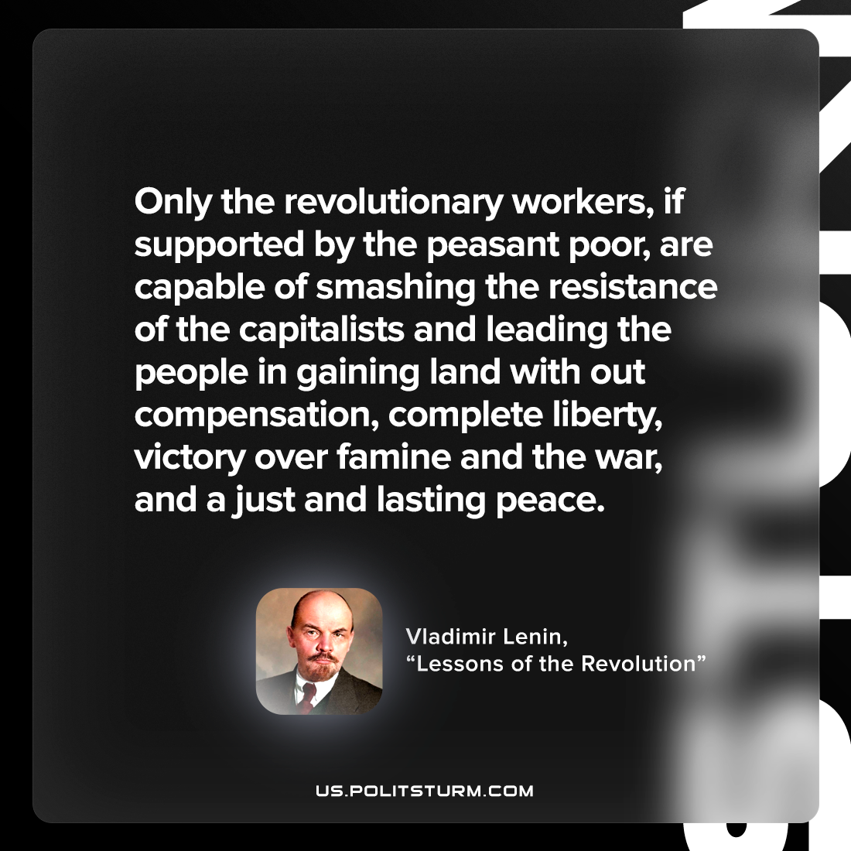

Original article
2022-08-14

Only the revolutionary workers, if supported by the peasant poor, are capable of smashing the resistance of the capitalists and leading the people in gaining land without compensation, complete liberty, victory over famine and the war, and a just and lasting peace.

Vladimir Lenin, “Lessons of the Revolution”

Original article

