Lenin on Revolutionary Violence
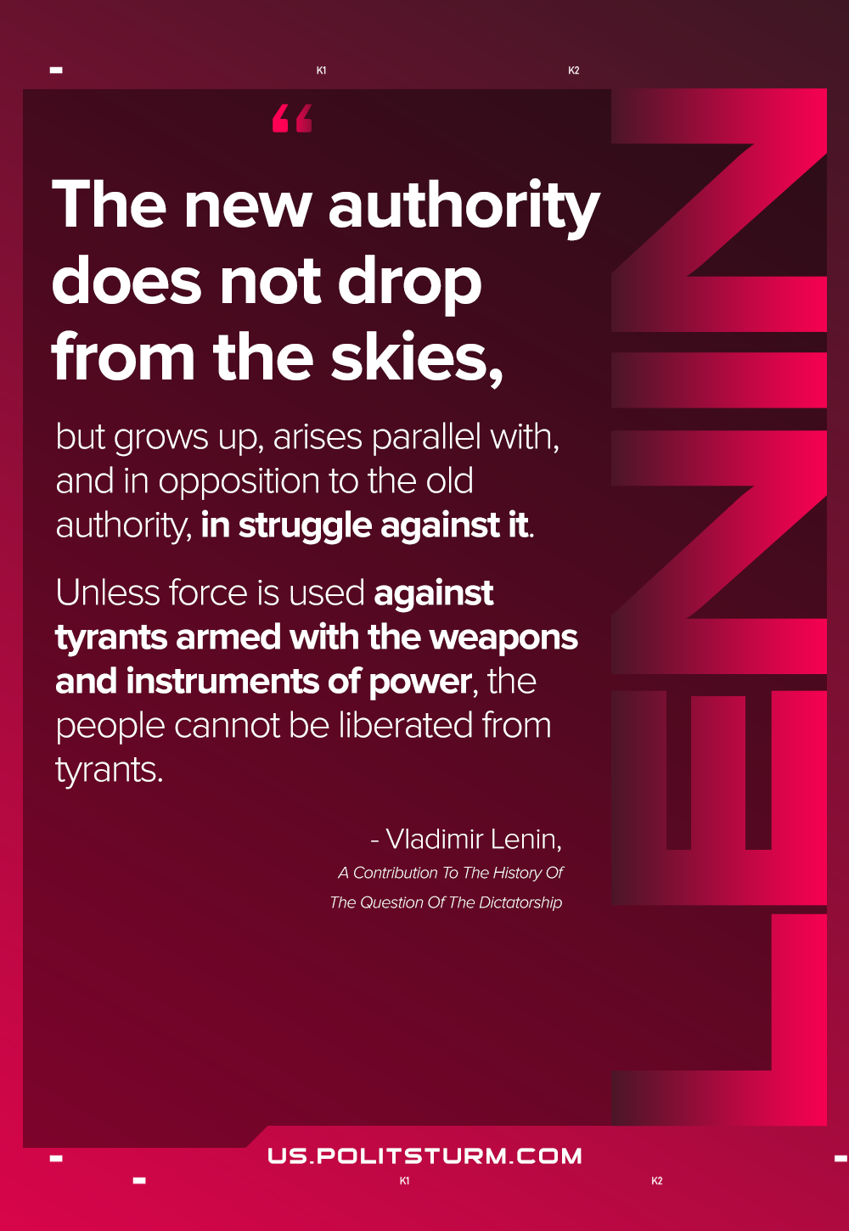

Original article
2021-05-02

… the new authority does not drop from the skies, but grows up, arises parallel with, and in opposition to the old authority, in struggle against it. Unless force is used against tyrants armed with the weapons and instruments of power, the people cannot be liberated from tyrants.
A Contribution To The History Of The Question Of The Dictatorship

Original article

