Lenin on Revolutionary Theory
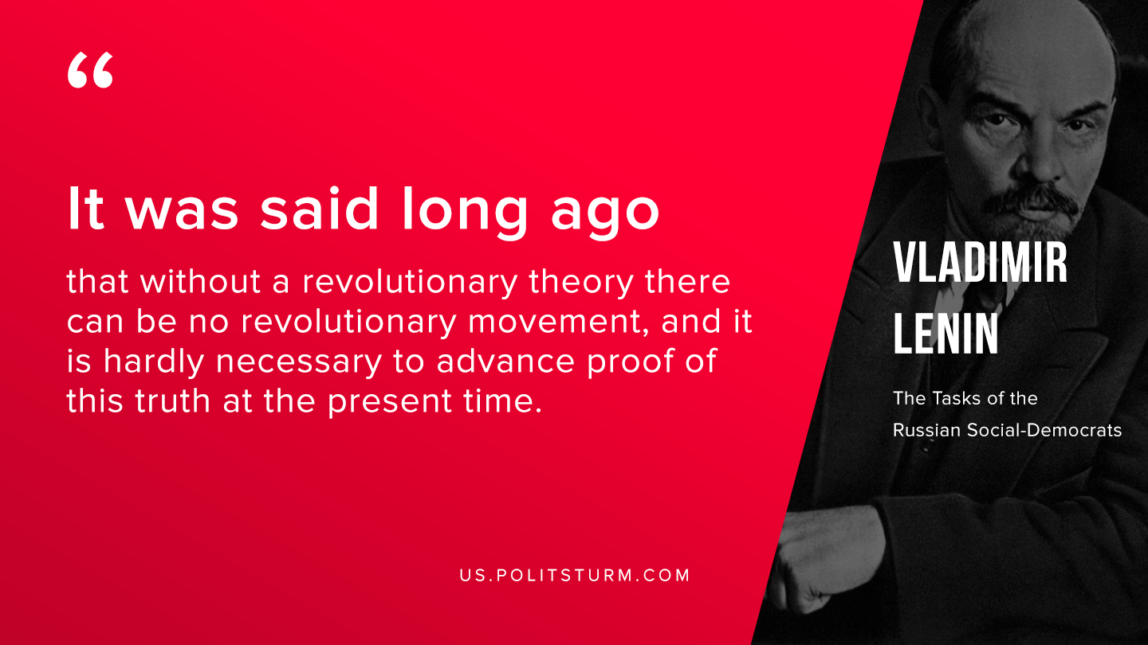

Original article
2019-09-01

It was said long ago that without a revolutionary theory there can be no revolutionary movement, and it is hardly necessary to advance proof of this truth at the present time.
Vladimir Lenin “The Tasks of the Russian Social-Democrats”

Original article

