Lenin on Revolutionary Theory
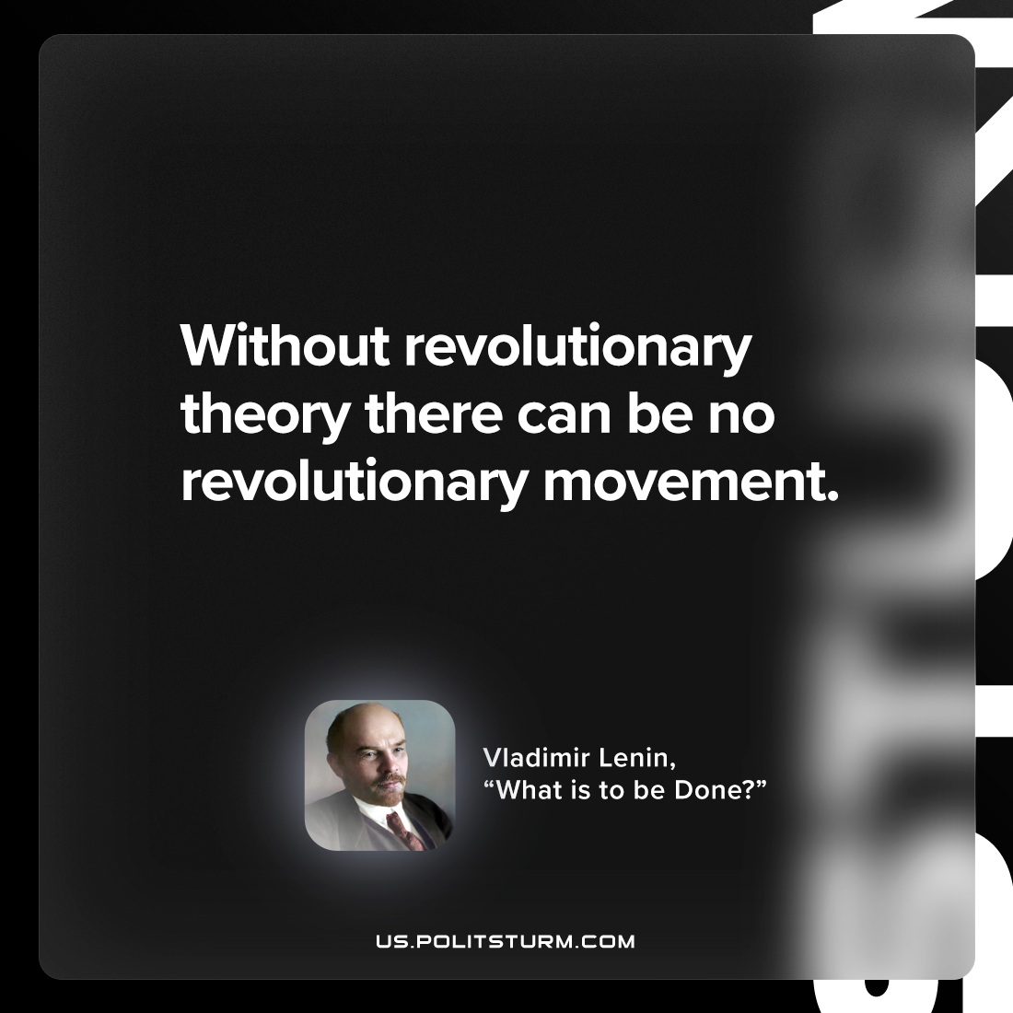

Original article
2023-01-14

"Without revolutionary theory there can be no revolutionary movement."
Vladimir Lenin, “What Is To Be Done?”

Original article

