Lenin on Religion
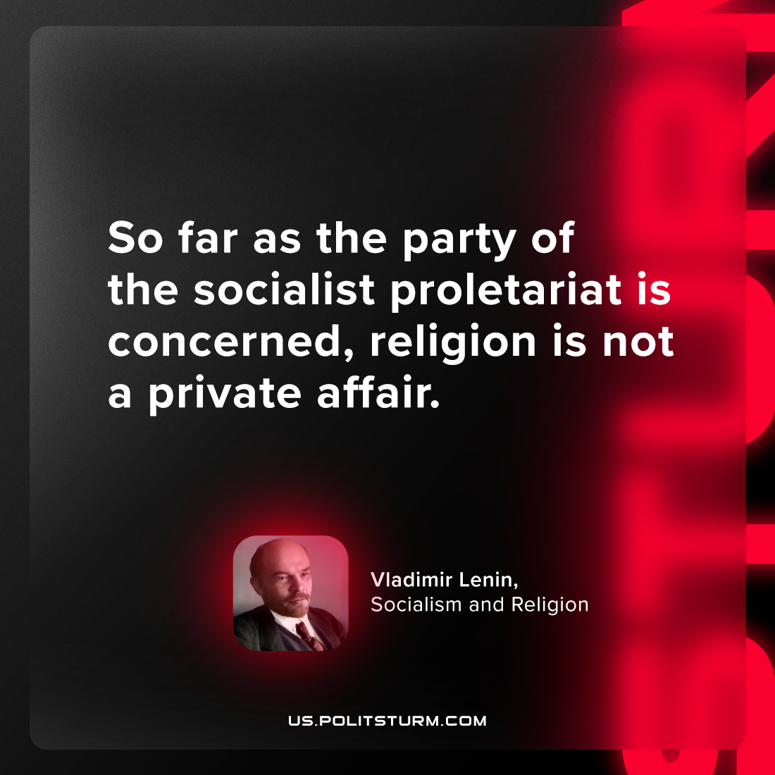

Original article
2024-05-02

“So far as the party of the socialist proletariat is concerned, religion is not a private affair.”
Vladimir Lenin, Socialism and Religion

Original article

