Lenin on a Reformist Transition
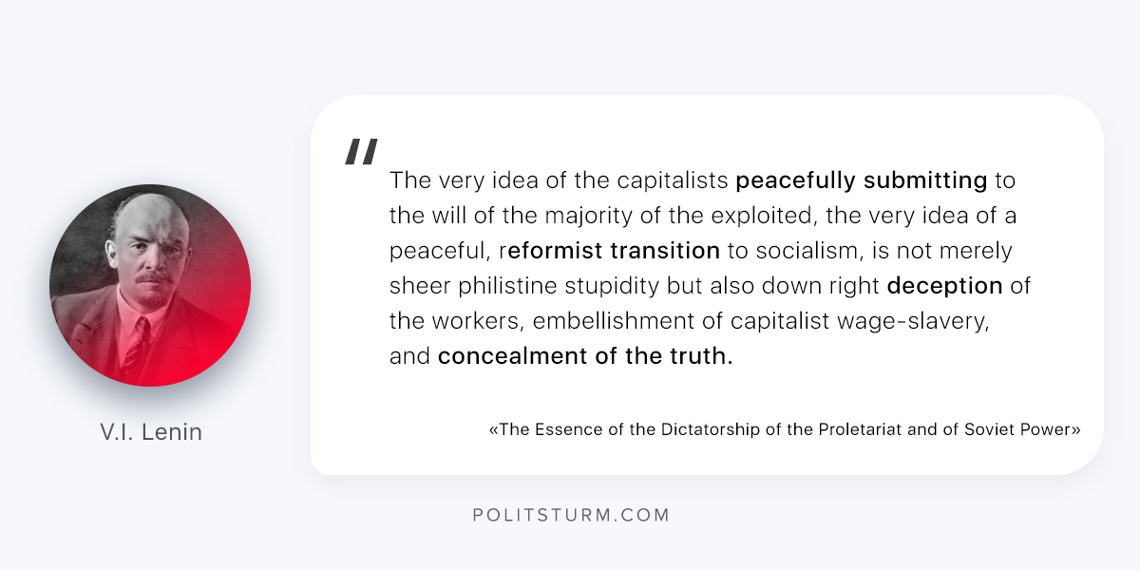

Original article
2018-07-02

“The very idea of the capitalists peacefully submitting to the will of the majority of the exploited, the very idea of a peaceful, reformist transition to socialism, is not merely sheer philistine stupidity but also down right deception of the workers, embellishment of capitalist wage-slavery, and concealment of the truth.”
V.I. Lenin, “The Essence of the Dictatorship of the Proletariat and of Soviet Power”

Original article

