Lenin on Reformism
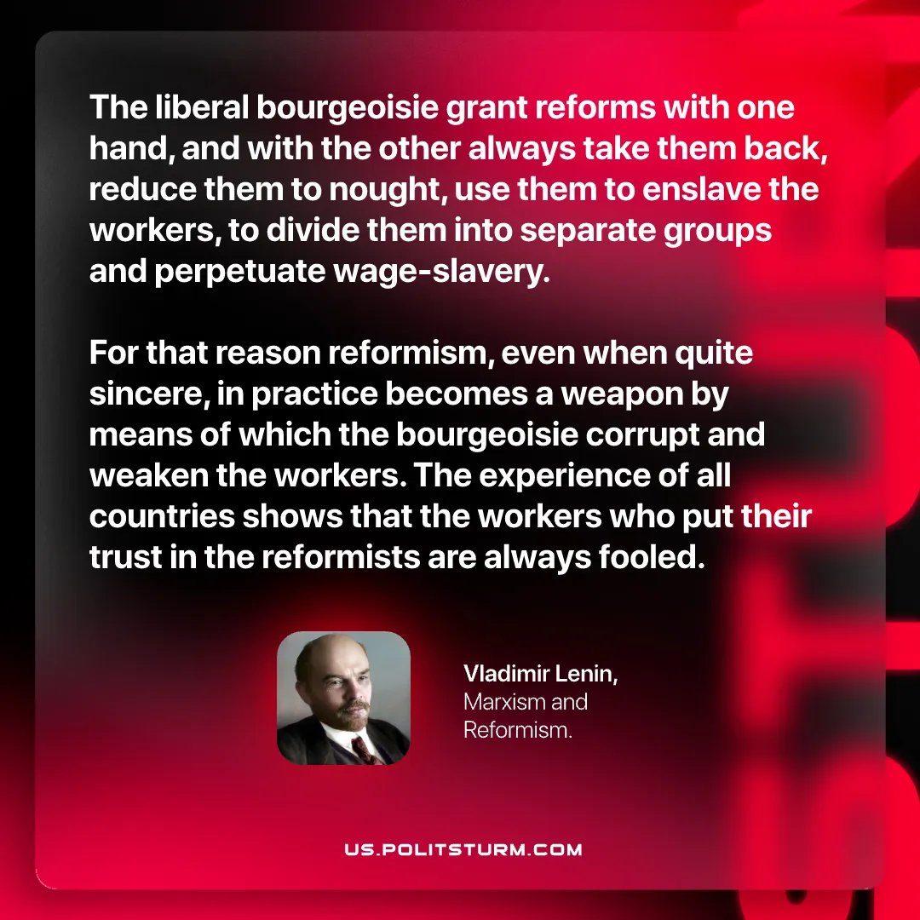

Original article
2026-07-25

The liberal bourgeoisie grant reforms with one hand, and with the other always take them back, reduce them to nought, use them to enslave the workers, to divide them into separate groups and perpetuate wage‑slavery.
For that reason reformism, even when quite sincere, in practice becomes a weapon by means of which the bourgeoisie corrupt and weaken the workers. The experience of all countries shows that the workers who put their trust in the reformists are always fooled.
Vladimir Lenin, Marxism and Reformism

Original article

