Lenin on Proper Agitation
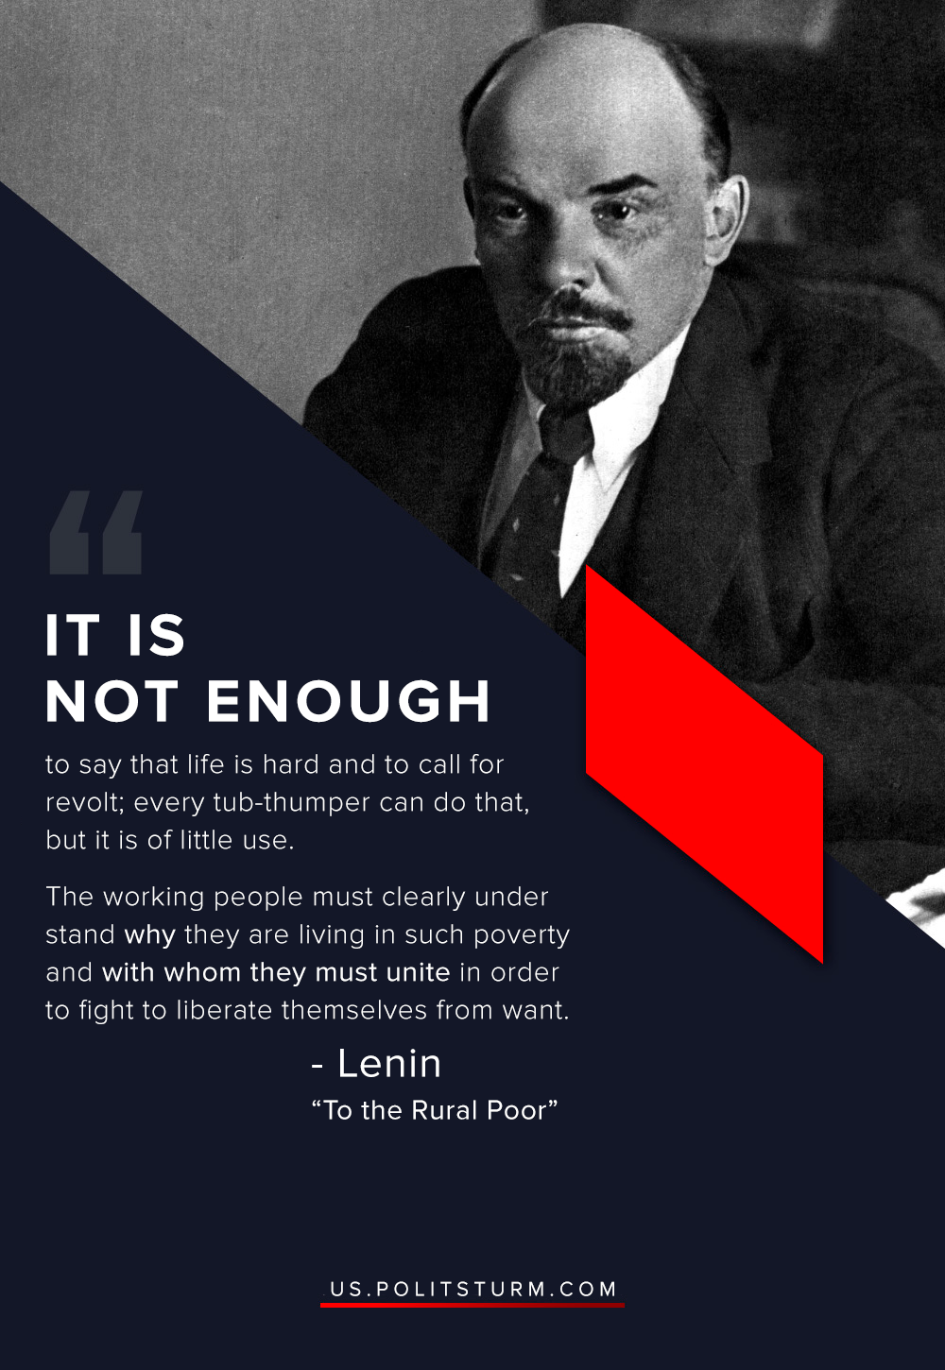

Original article
2020-05-16

His words are still important for the modern communist movement.

Original article

