Lenin on the International Proletariat Class Solidarity
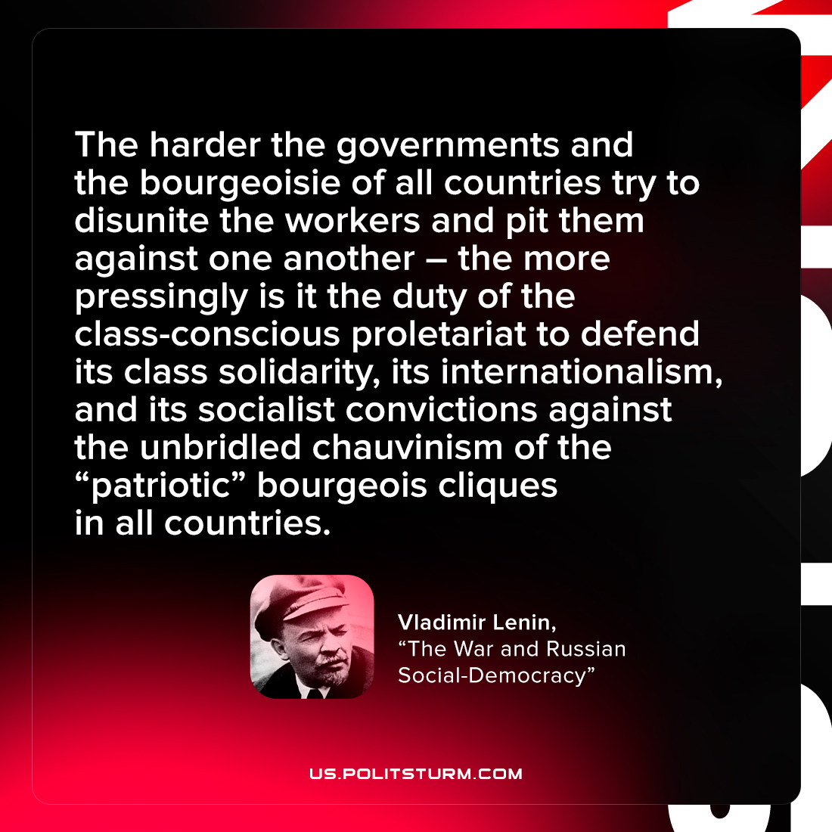

Original article
2022-02-28
1 min read

The harder the governments and the bourgeoisie of all countries try to disunite the workers and pit them against one another, and the more savagely they enforce, for this lofty aim, martial law and the military censorship (measures which even now, in wartime, are applied against the “internal” foe more harshly than against the external), the more pressingly is it the duty of the class-conscious proletariat to defend its class solidarity, its internationalism, and its socialist convictions against the unbridled chauvinism of the “patriotic” bourgeois cliques in all countries.

Vladimir Lenin, “The War and Russian Social-Democracy”

Original article

