Lenin on Productive Forces
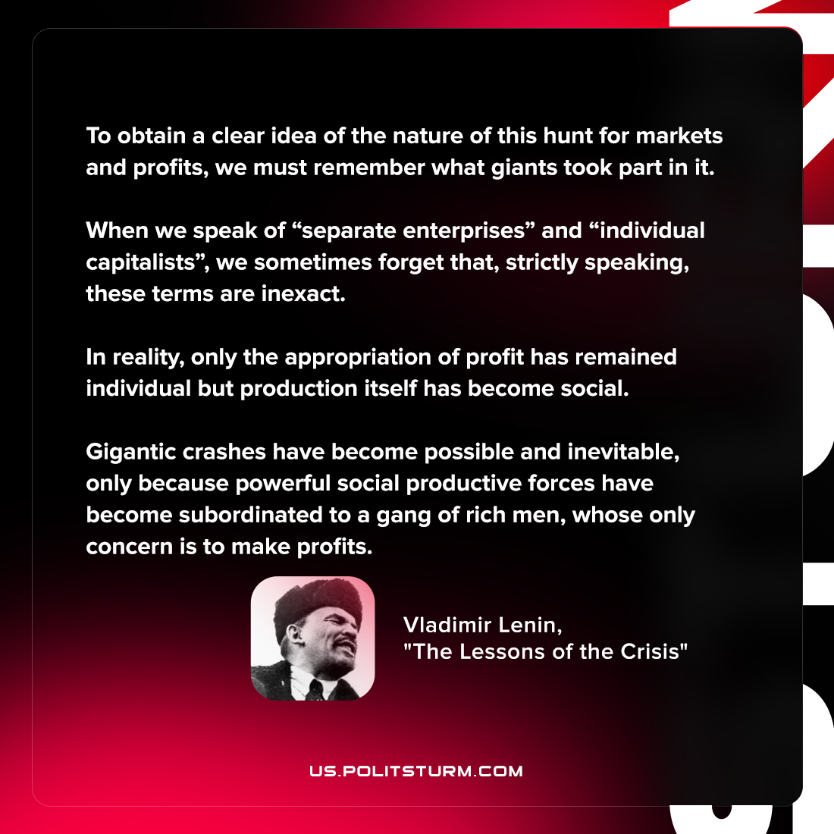

Original article
2022-05-20
1 min read

To obtain a clear idea of the nature of this hunt for markets and profits, we must remember what giants took part in it. When we speak of “separate enterprises” and “individual capitalists”, we sometimes forget that, strictly speaking, these terms are inexact. In reality, only the appropriation of profit has remained individual but production itself has become social. Gigantic crashes have become possible and inevitable, only because powerful social productive forces have become subordinated to a gang of rich men, whose only concern is to make profits.

Vladimir Lenin, “The Lessons of the Crisis”

Original article

