Lenin on Private and State Monopolies in the Era of Financial Capital
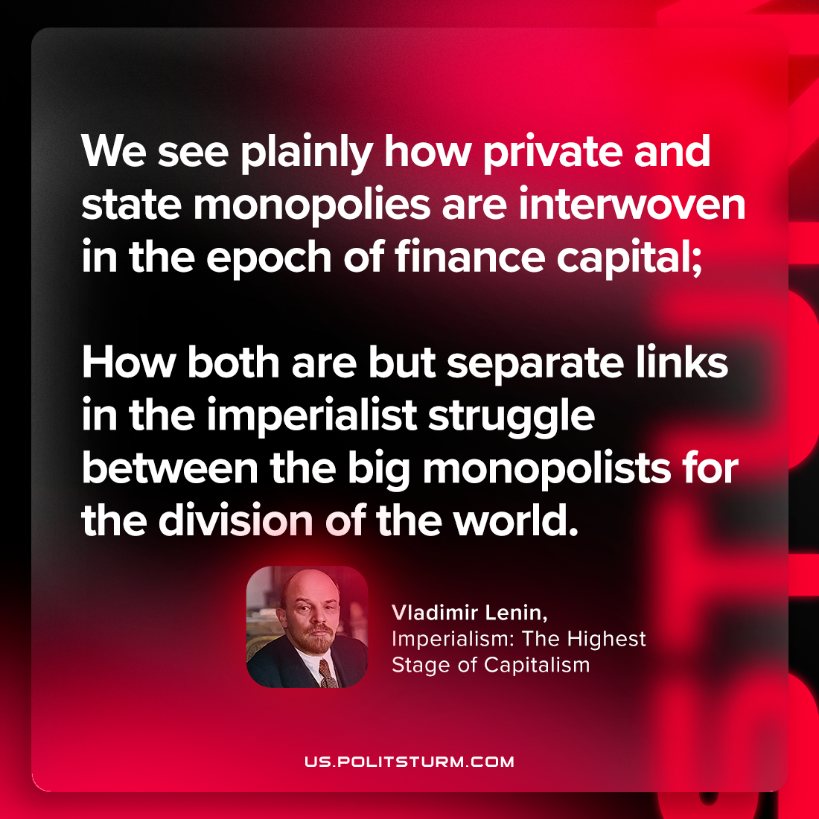

Original article
2023-11-25

"We see plainly how private and state monopolies are interwoven in the epoch of finance capital; how both are but separate links in the imperialist struggle between the big monopolists for the division of the world."
Vladimir Lenin, Imperialism: the Highest Stage of Capitalism

Original article

