Lenin on Primitive Accumulation
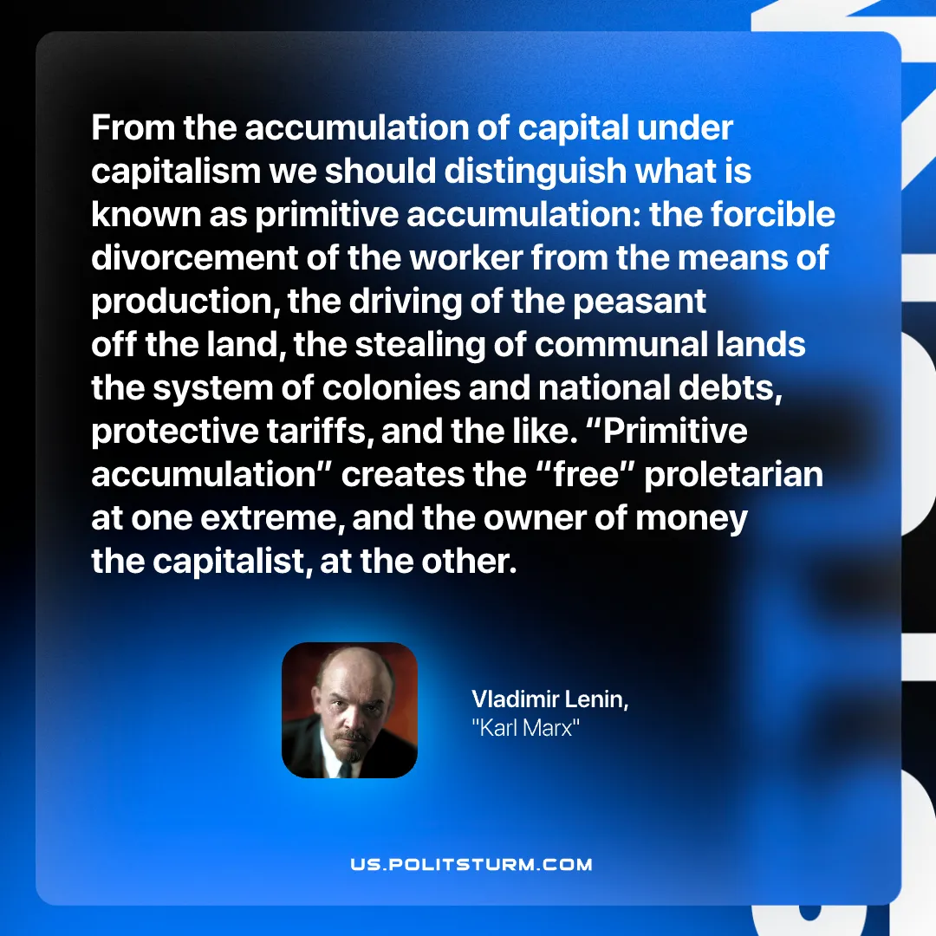

Original article
2026-02-12

“From the accumulation of capital under capitalism we should distinguish what is known as primitive accumulation: the forcible divorcement of the worker from the means of production, the driving of the peasant off the land, the stealing of communal lands, the system of colonies and national debts, protective tariffs, and the like. “Primitive accumulation” creates the “free” proletarian at one extreme, and the owner of money, the capitalist, at the other.”
Vladimir Lenin, “Karl Marx”

Original article

