Lenin on Present-day Society
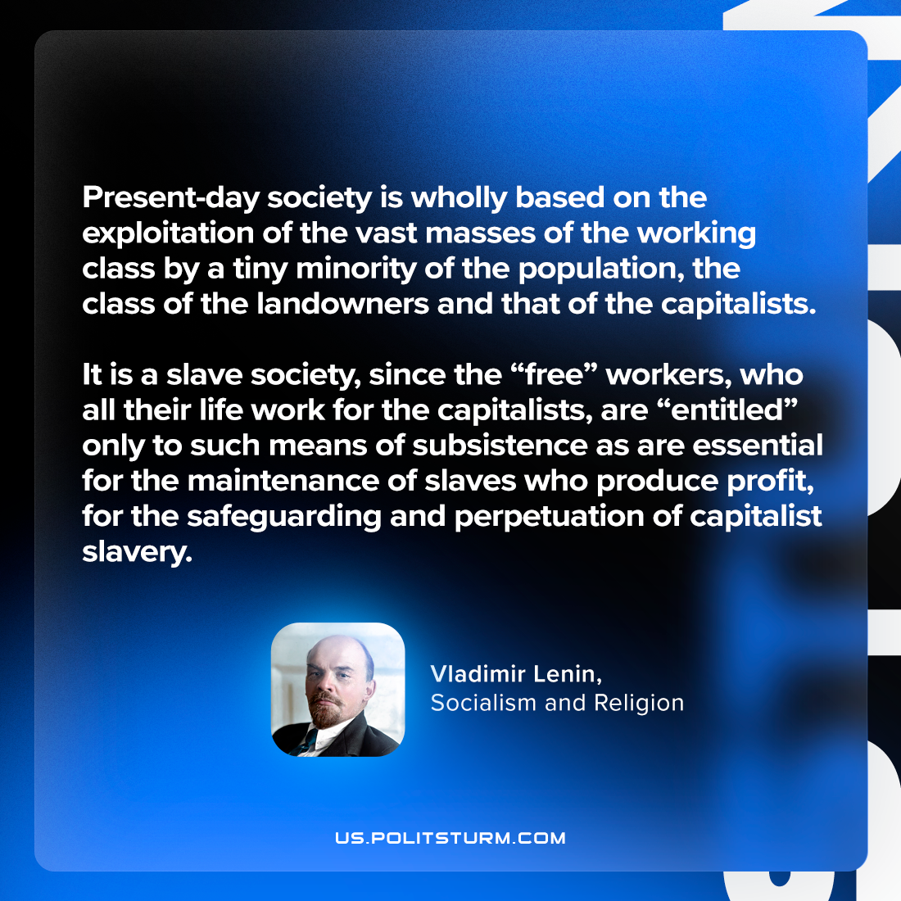

Original article
2024-02-10

"Present-day society is wholly based on the exploitation of the vast masses of the working class by a tiny minority of the population, the class of the landowners and that of the capitalists. It is a slave society, since the “free” workers, who all their life work for the capitalists, are “entitled” only to such means of subsistence as are essential for the maintenance of slaves who produce profit, for the safeguarding and perpetuation of capitalist slavery."
Vladimir Lenin, Socialism and religion

Original article

