Lenin on "Practicality" in the National Question
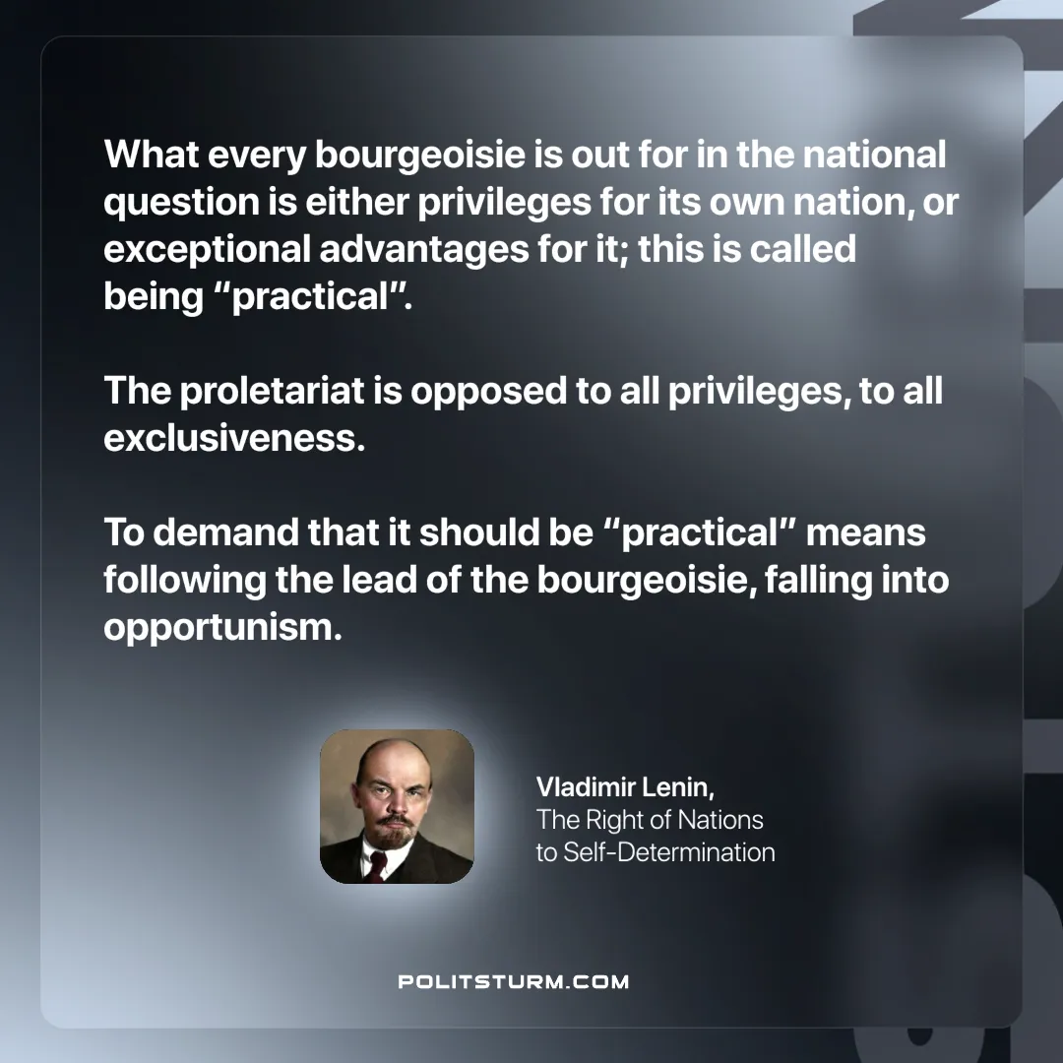

Original article
2024-10-24

“What every bourgeoisie is out for in the national question is either privileges for its own nation, or exceptional advantages for it; this is called being “practical”. The proletariat is opposed to all privileges, to all exclusiveness. To demand that it should be “practical” means following the lead of the bourgeoisie, falling into opportunism.”
Vladimir Lenin, The Right of Nations to Self-Determination

Original article

