Lenin on Political Revolution
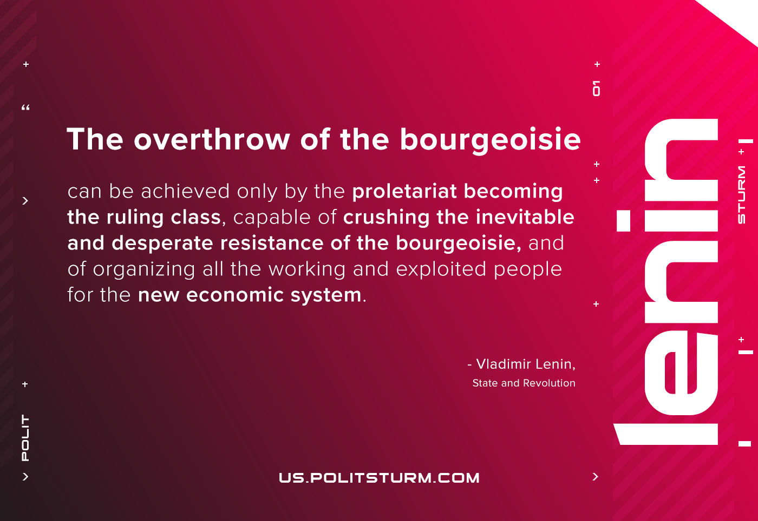

Original article
2021-03-02

The overthrow of the bourgeoisie can be achieved only by the proletariat becoming the ruling class, capable of crushing the inevitable and desperate resistance of the bourgeoisie, and of organizing all the working and exploited people for the new economic system.
Lenin, State and Revolution

Original article

