Lenin on Political Consciousness and Revolutionary Struggle
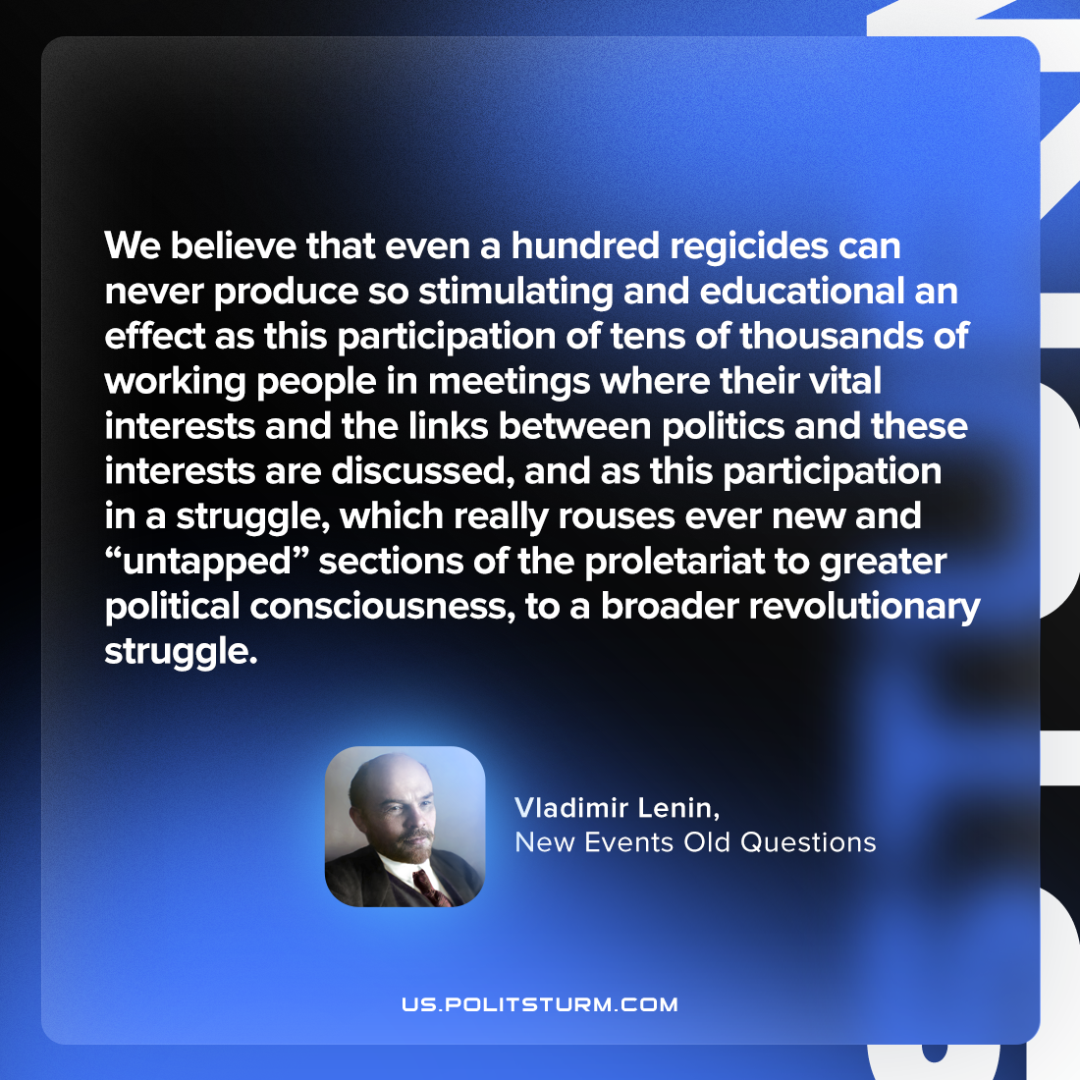

Original article
2023-06-29

"We believe that even a hundred regicides can never produce so stimulating and educational an effect as this participation of tens of thousands of working people in meetings where their vital interests and the links between politics and these interests are discussed, and as this participation in a struggle, which really rouses ever new and “untapped” sections of the proletariat to greater political consciousness, to a broader revolutionary struggle."
Vladimir Lenin, New Events Old Questions

Original article

