Lenin on Petty-Bourgeois World-Outlook
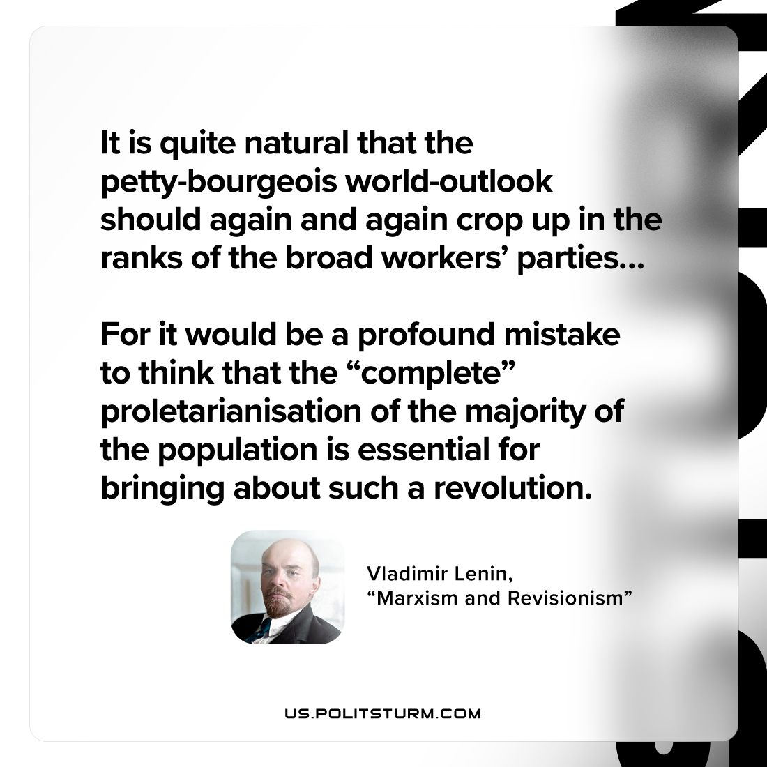

Original article
2023-02-09

"It is quite natural that the petty-bourgeois world-outlook should again and again crop up in the ranks of the broad workers’ parties… For it would be a profound mistake to think that the “complete” proletarianisation of the majority of the population is essential for bringing about such a revolution."
Vladimir Lenin, “Marxism and Revisionism”

Original article

