Lenin on Petty Bourgeois Ambitions
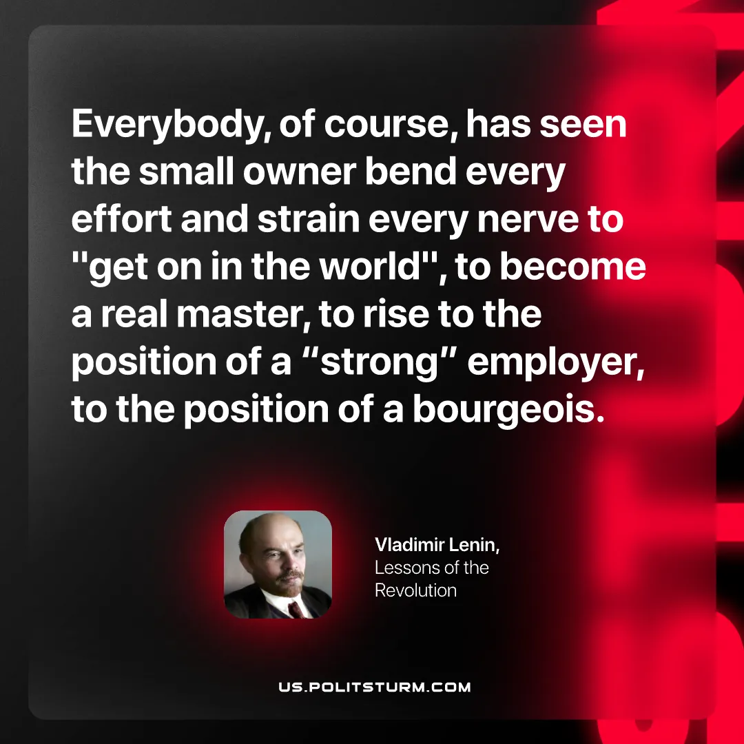

Original article
2026-10-20

Everybody, of course, has seen the small owner bend every effort and strain every nerve to "get on in the world", to become a real master, to rise to the position of a "strong" employer, to the position of a bourgeois.
Vladimir Lenin, Lessons of the Revolution

Original article

