Lenin on Peasantry and Class Struggle
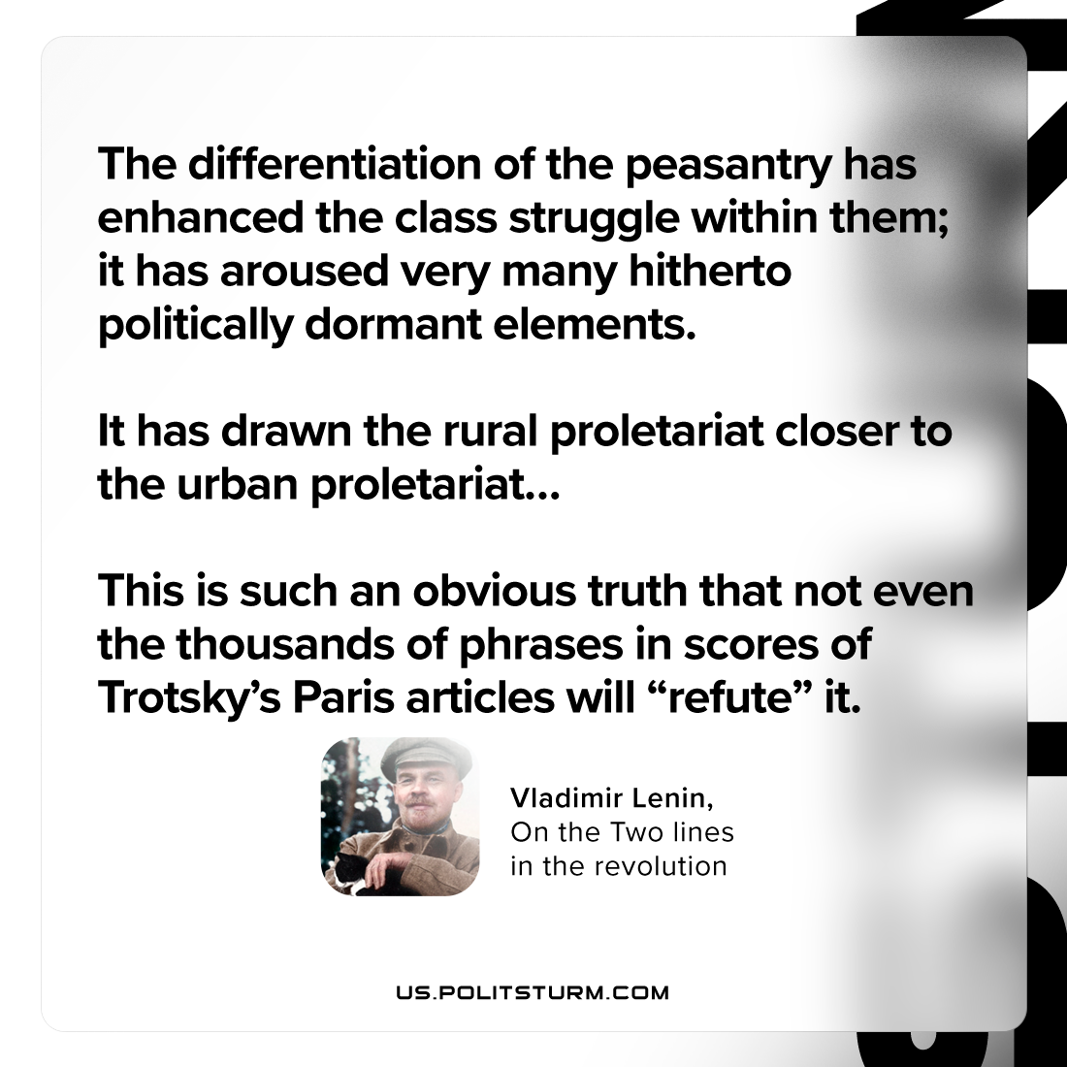

Original article
2023-08-08

"The differentiation of the peasantry has enhanced the class struggle within them; it has aroused very many hitherto politically dormant elements. It has drawn the rural proletariat closer to the urban proletariat… This is such an obvious truth that not even the thousands of phrases in scores of Trotsky’s Paris articles will “refute” it. "
Vladimir Lenin, On the Two Lines in the Revolution

Original article

