Lenin on Parliamentarism
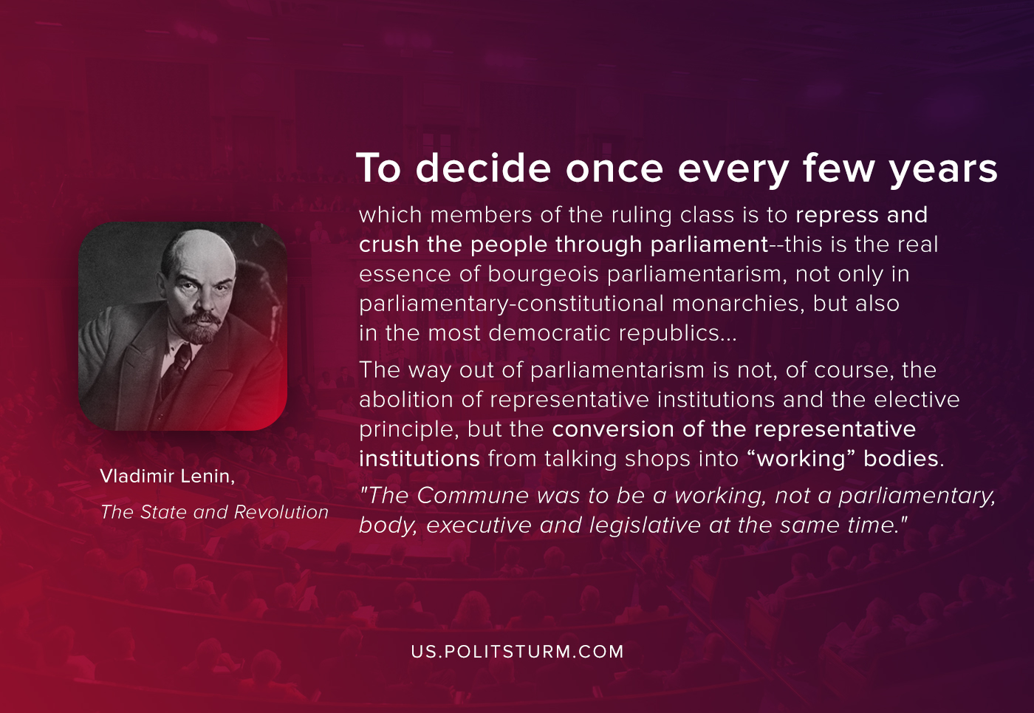

Original article
2020-07-29
1 min read

To decide once every few years which members of the ruling class is to repress and crush the people through parliament–this is the real essence of bourgeois parliamentarism, not only in parliamentary- constitutional monarchies, but also in the most democratic republics.
But if we deal with the question of the state, and if we consider parliamentarism as one of the institutions of the state, from the point of view of the tasks of the proletariat in this field, what is the way out of parliamentarism? How can it be dispensed with?
Once again, we must say: the lessons of Marx, based on the study of the Commune, have been so completely forgotten that the present-day “Social-Democrat” (i.e., present-day traitor to socialism) really cannot understand any criticism of parliamentarism other than anarchist or reactionary criticism.
The way out of parliamentarism is not, of course, the abolition of representative institutions and the elective principle, but the conversion of the representative institutions from talking shops into “working” bodies. “The Commune was to be a working, not a parliamentary, body, executive and legislative at the same time.”
Vladimir Lenin, “The State and Revolution”

Original article

