Lenin on Organizational Work
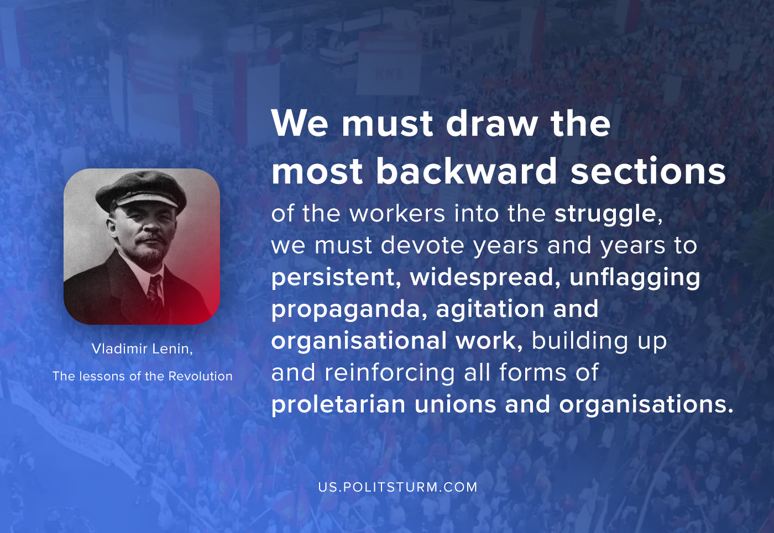

Original article
2020-10-17

We must draw the most backward sections of the workers into the struggle, we must devote years and years to persistent, widespread, unflagging propaganda, agitation and organizational work, building up and reinforcing all forms of proletarian unions and organisations.
Vladimir Lenin, The Lessons of the Revolution.

Original article

