Lenin on Organisation and Policy
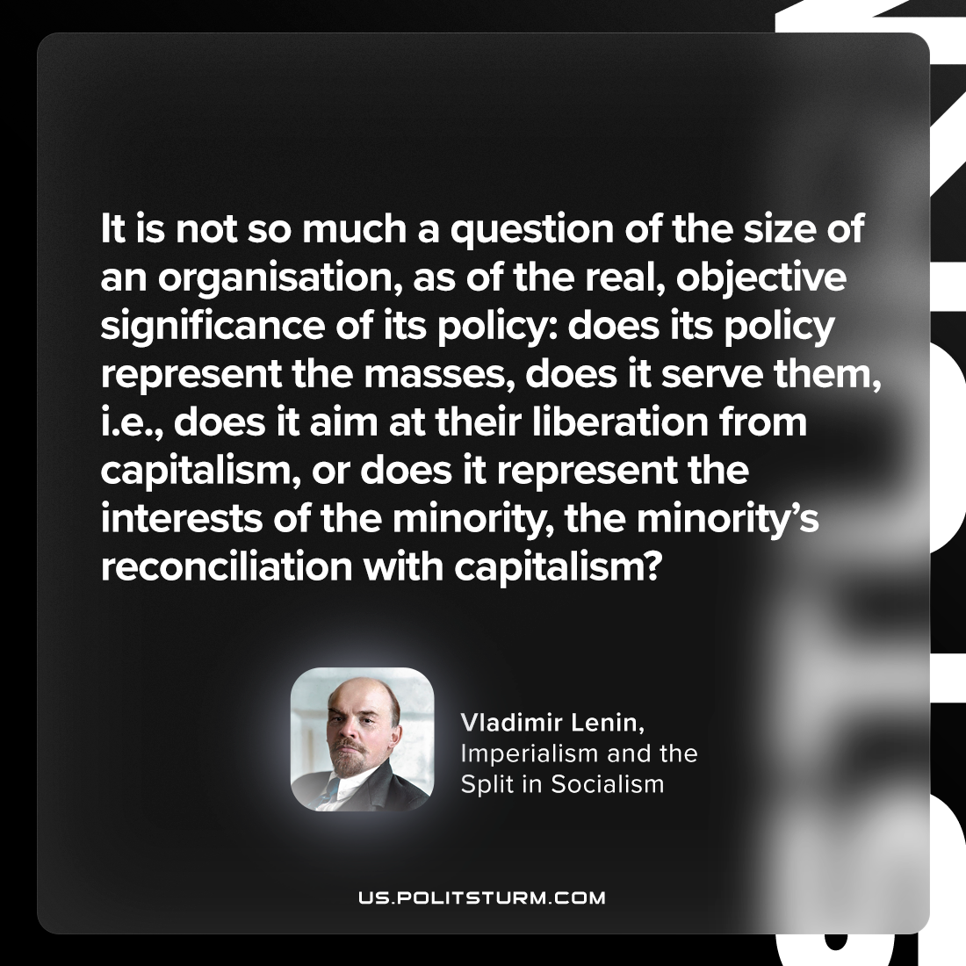

Original article
2023-04-11

"It is not so much a question of the size of an organisation, as of the real, objective significance of its policy: does its policy represent the masses, does it serve them, i.e., does it aim at their liberation from capitalism, or does it represent the interests of the minority, the minority’s reconciliation with capitalism?"
Vladimir Lenin, “Imperialism and the Split in Socialism”

Original article

