Lenin on Opportunist Attitudes Towards the State
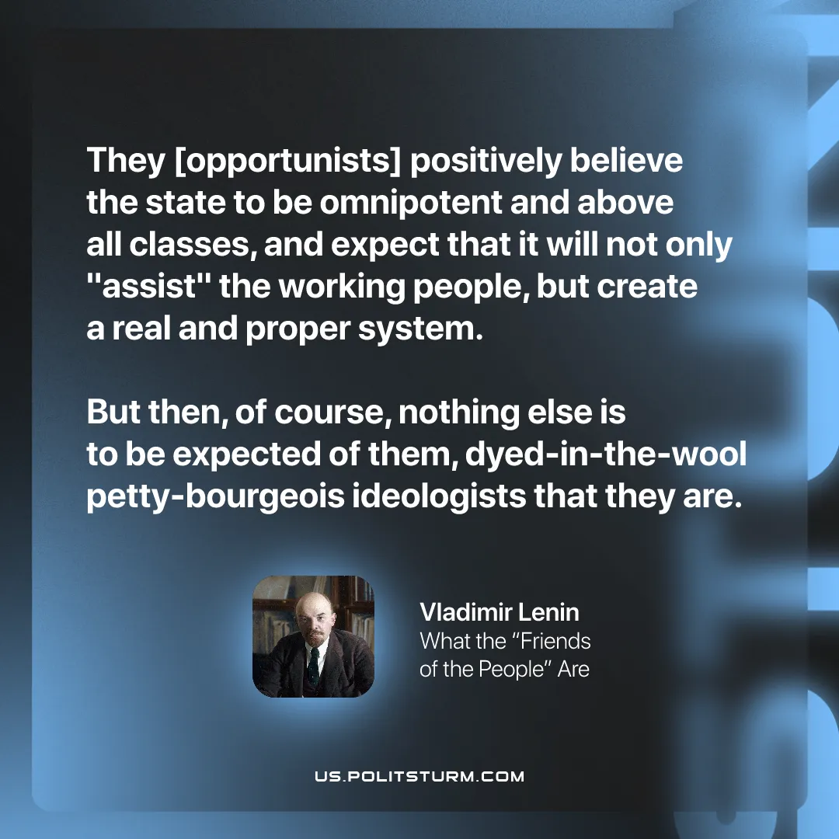

Original article
2026-01-27

“They [opportunists] positively believe the state to be omnipotent and above all classes, and expect that it will not only "assist" the working people, but create a real and proper system. But then, of course, nothing else is to be expected of them, dyed-in-the-wool petty-bourgeois ideologists that they are.”
Vladimir Lenin, What the “Friends of the People” Are

Original article

