Lenin on Opportunism and Chauvinism
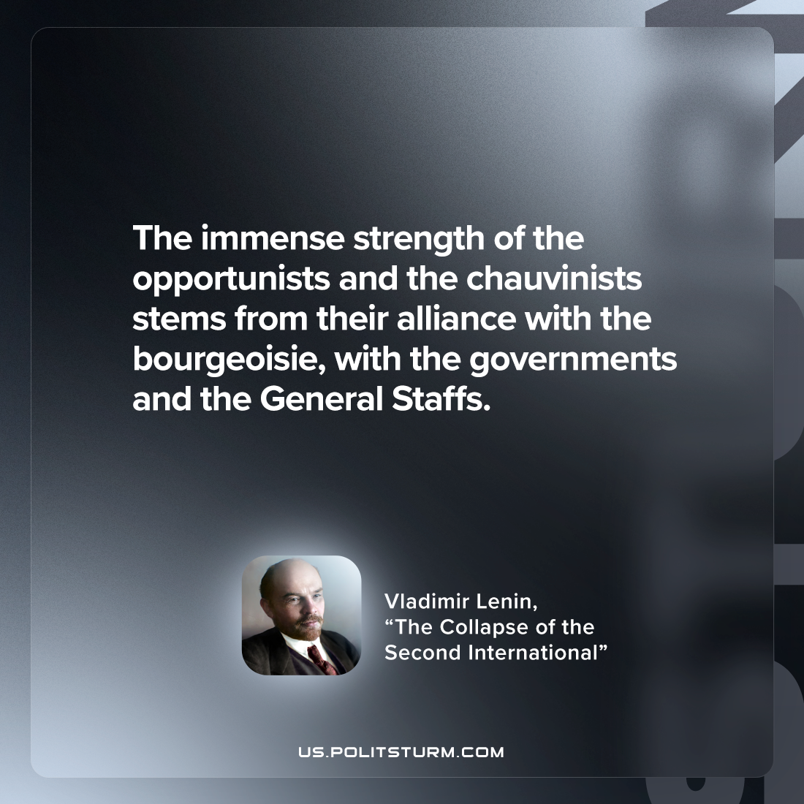

Original article
2022-12-10

"The immense strength of the opportunists and the chauvinists stems from their alliance with the bourgeoisie, with the governments and the General Staffs."
Vladimir Lenin, “The Collapse of the Second International”

Original article

