Lenin on Old and New Forms of Capitalism
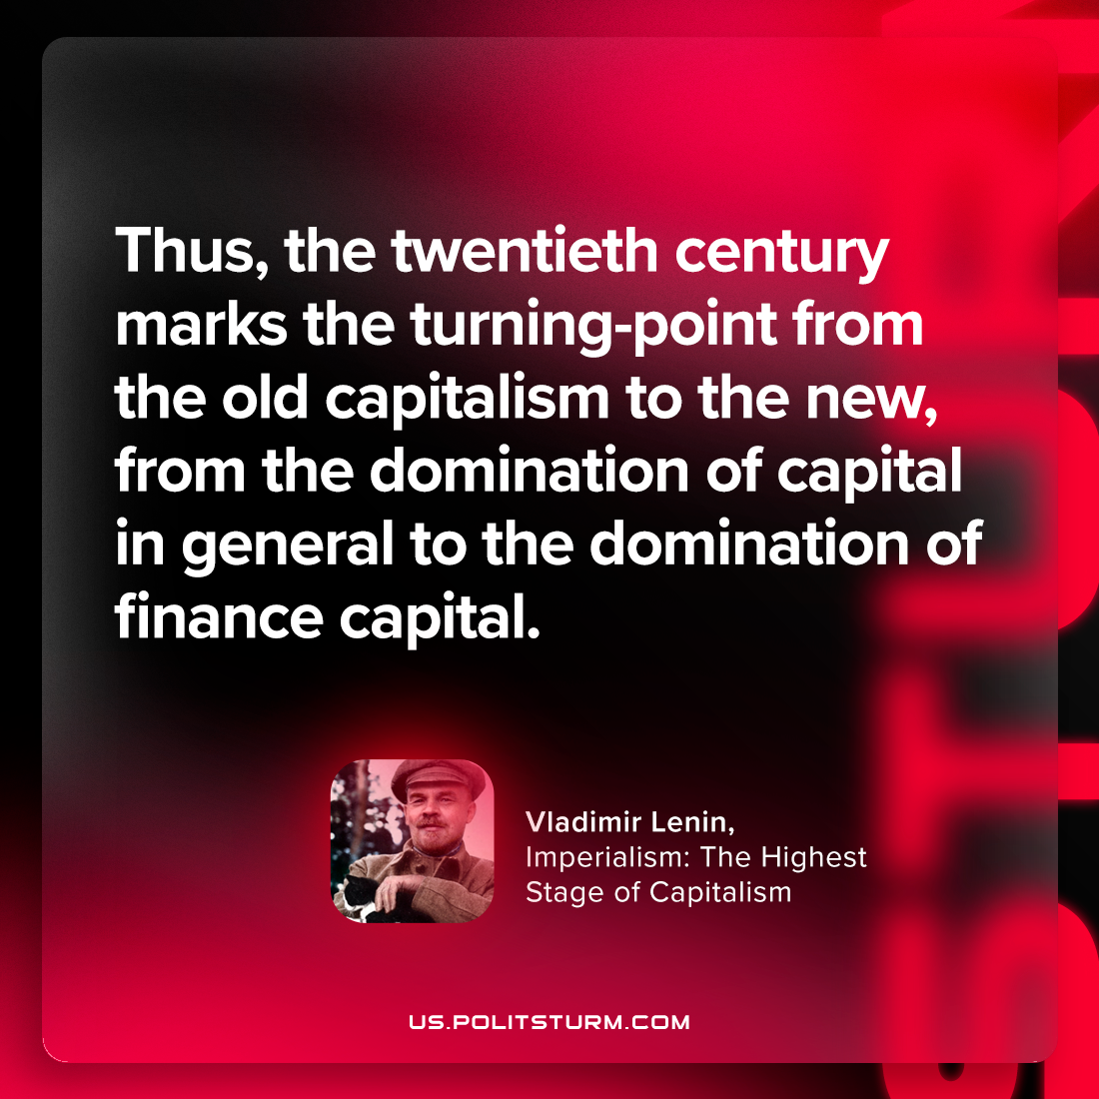

Original article
2023-09-14

"Thus, the twentieth century marks the turning-point from the old capitalism to the new, from the domination of capital in general to the domination of finance capital."
Vladimir Lenin, Imperialism: the Highest Stage of Capitalism

Original article

