Lenin on Need Strong Party Leadership
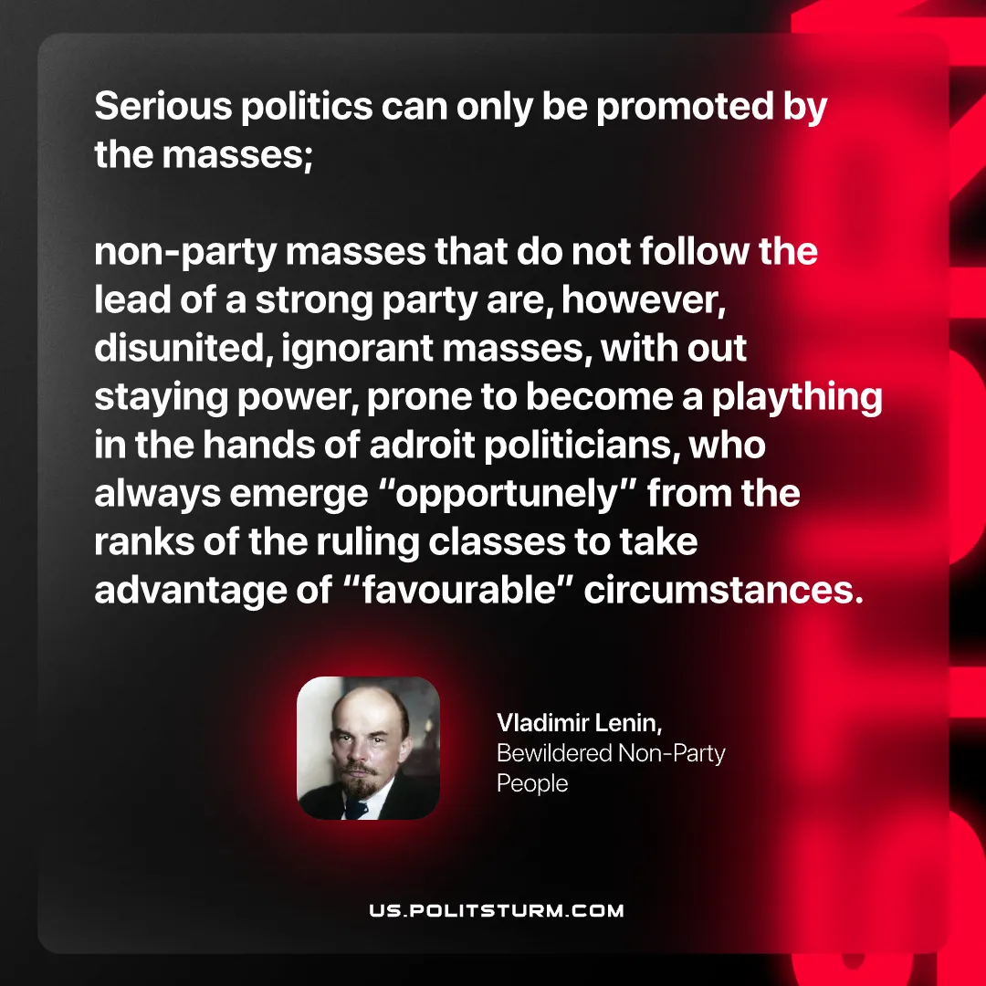

Original article
2026-10-11

Serious politics can only be promoted by the masses; non-party masses that do not follow the lead of a strong party are, however, disunited, ignorant masses, with out staying power, prone to become a plaything in the hands of adroit politicians, who always emerge "opportunely" from the ranks of the ruling classes to take advantage of "favourable" circumstances.
Vladimir Lenin, Bewildered Non-Party People

Original article

