Lenin on Nationalism
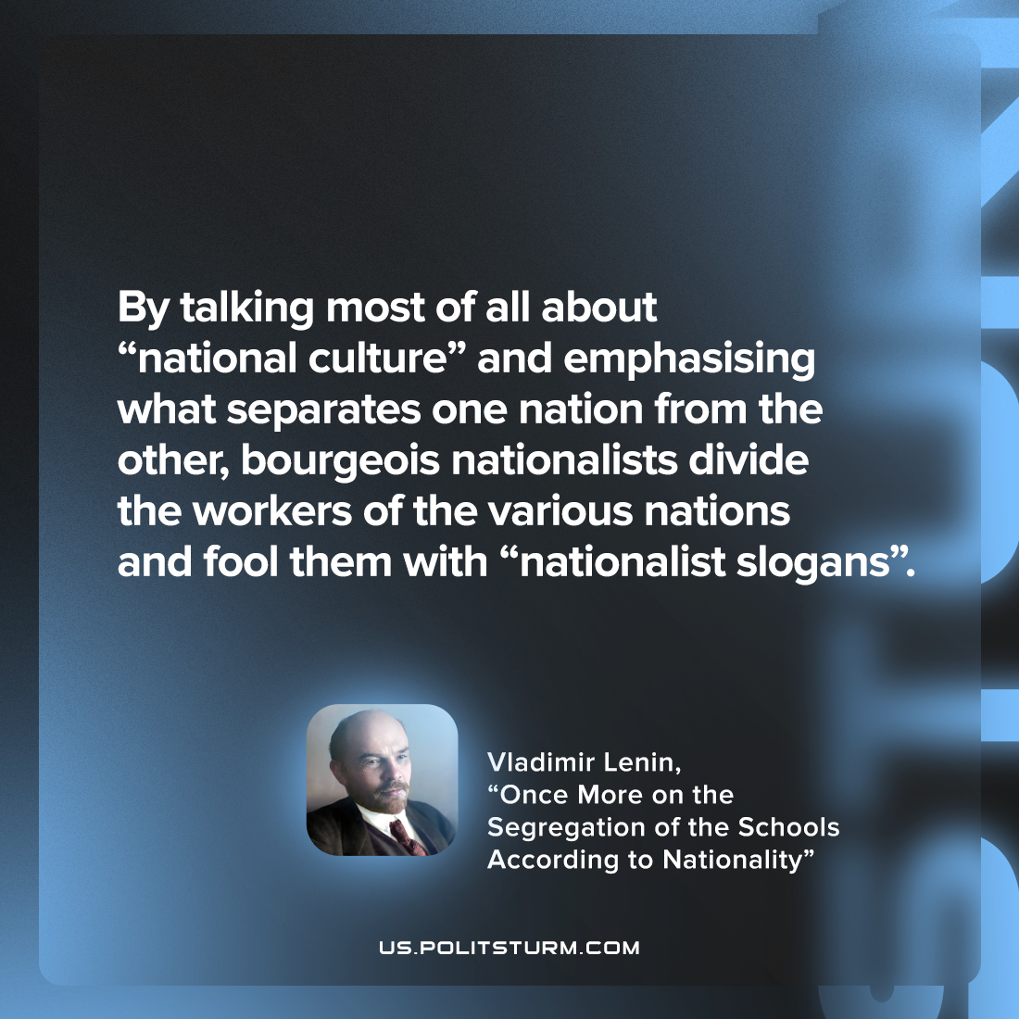

Original article
2022-10-28

By talking most of all about “national culture” and emphasising what separates one nation from the other, bourgeois nationalists divide the workers of the various nations and fool them with “nationalist slogans”.

Vladimir Lenin, “Once More on the Segregation of the Schools According to Nationality”

Original article

