Lenin on Monopoly and its Strategy
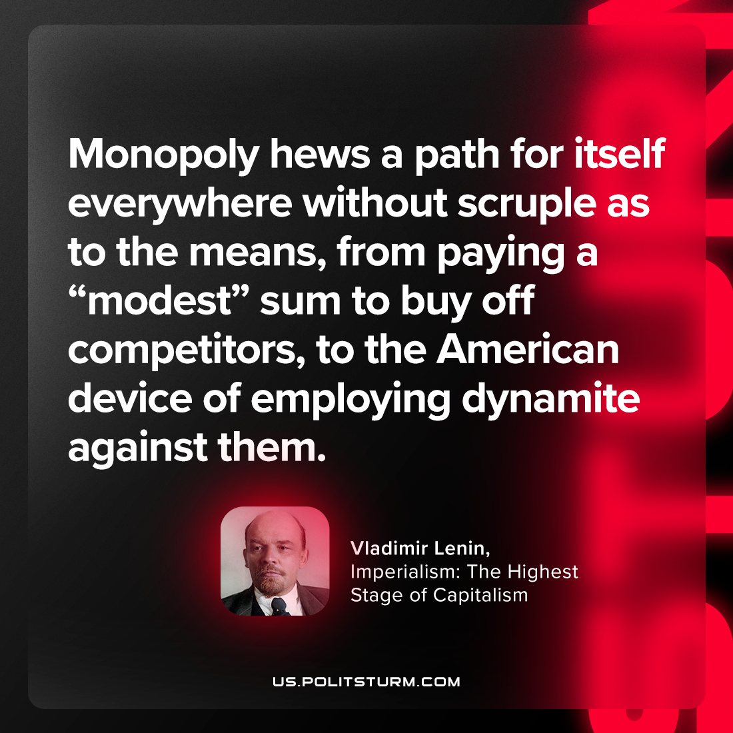

Original article
2023-09-10

"Monopoly hews a path for itself everywhere without scruple as to the means, from paying a “modest” sum to buy off competitors, to the American device of employing dynamite against them."
Vladimir Lenin, Imperialism: The Highest Stage of Capitalism

Original article

