Lenin on Monopoly and Colonial Policy
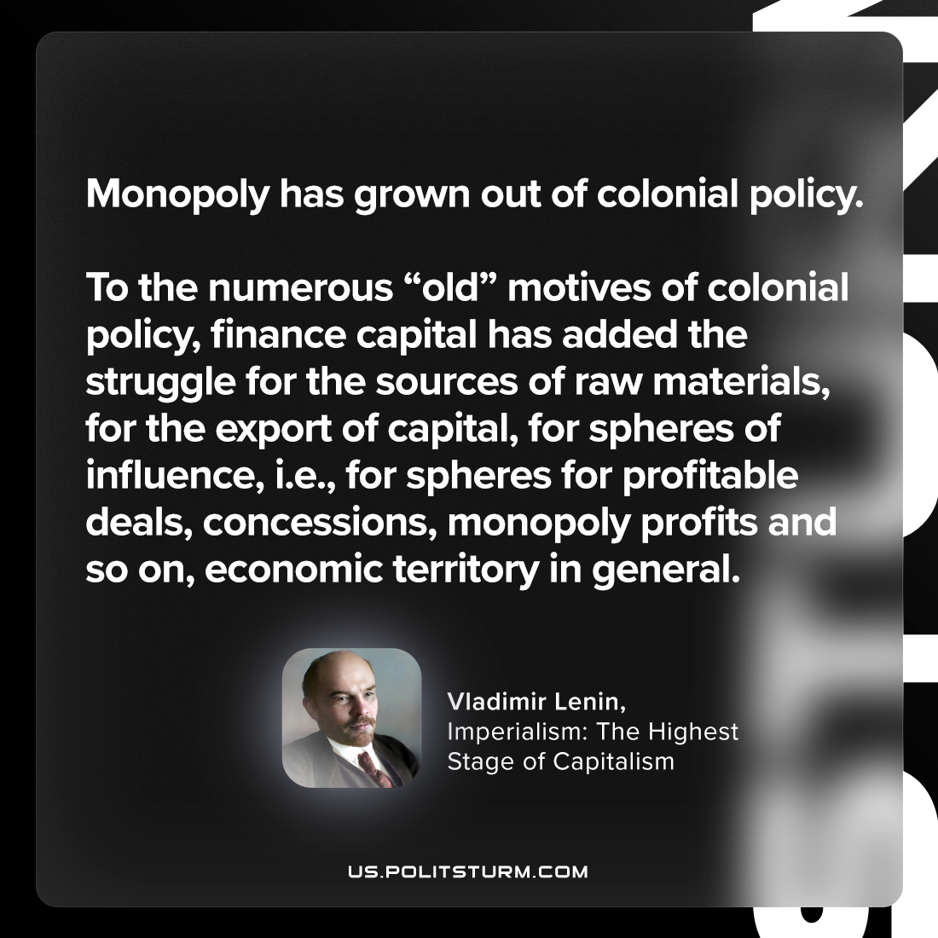

Original article
2024-04-16

“Monopoly has grown out of colonial policy. To the numerous “old” motives of colonial policy, finance capital has added the struggle for the sources of raw materials, for the export of capital, for spheres of influence, i.e., for spheres for profitable deals, concessions, monopoly profits and so on, economic territory in general.”
Vladimir Lenin, Imperialism: The Highest Stage of Capitalism

Original article

