Lenin on Monopolies, Cartels, Syndicates and Trusts
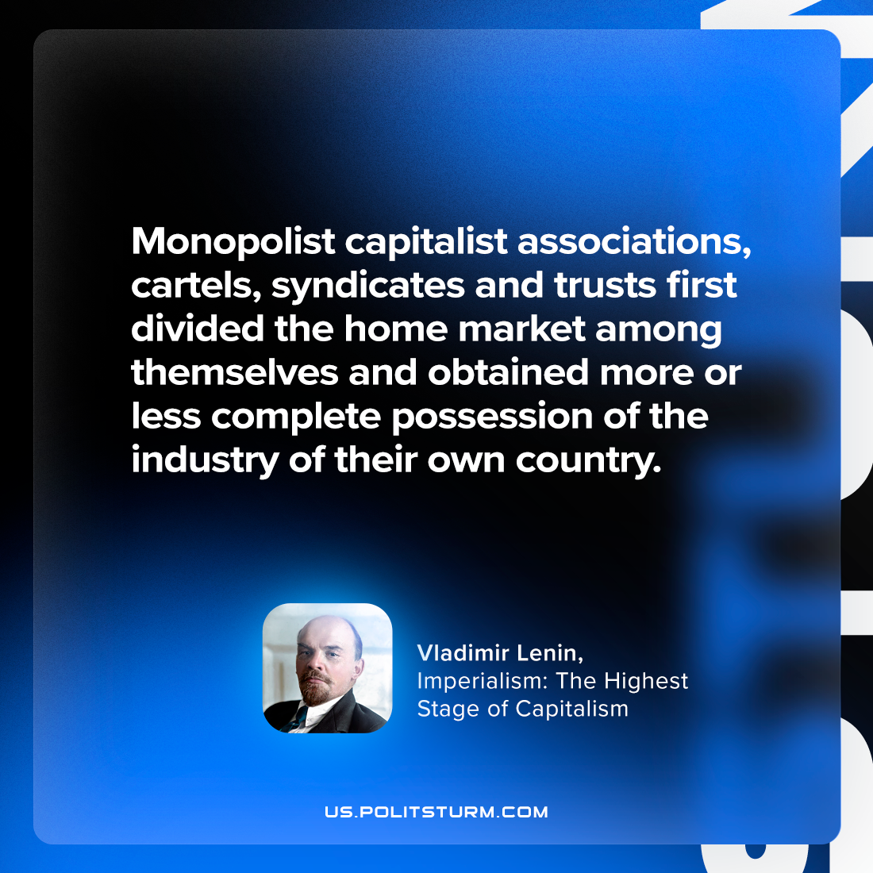

Original article
2023-10-28

"Monopolist capitalist associations, cartels, syndicates and trusts first divided the home market among themselves and obtained more or less complete possession of the industry of their own country."
Vladimir Lenin, Imperialism: the Highest Stage of Capitalism

Original article

