Lenin on Monopolies
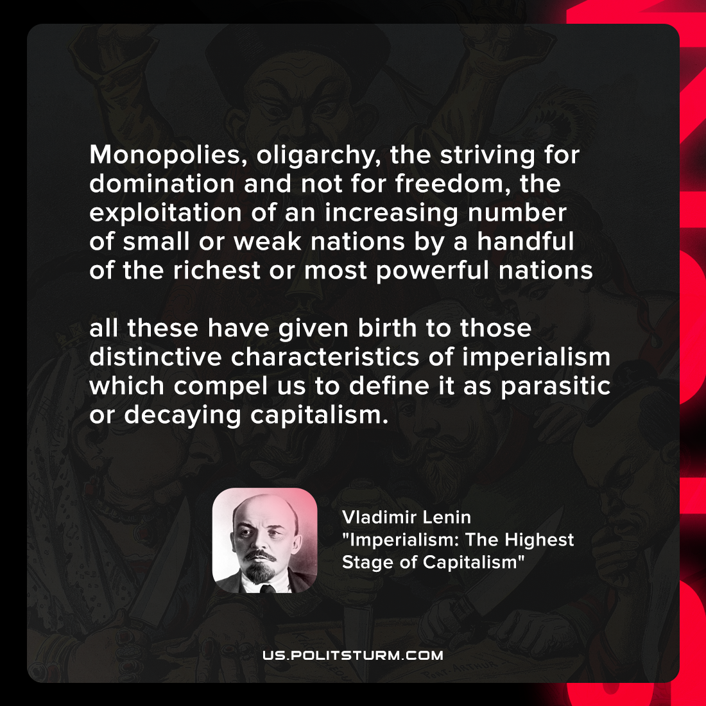

Original article
2021-11-26

Monopolies, oligarchy, the striving for domination and not for freedom, the exploitation of an increasing number of small or weak nations by a handful of the richest or most powerful nations — all these have given birth to those distinctive characteristics of imperialism which compel us to define it as parasitic or decaying capitalism.

Vladimir Lenin, “Imperialism: The Highest Stage of Capitalism”

Original article

