Lenin on Modern Militarism
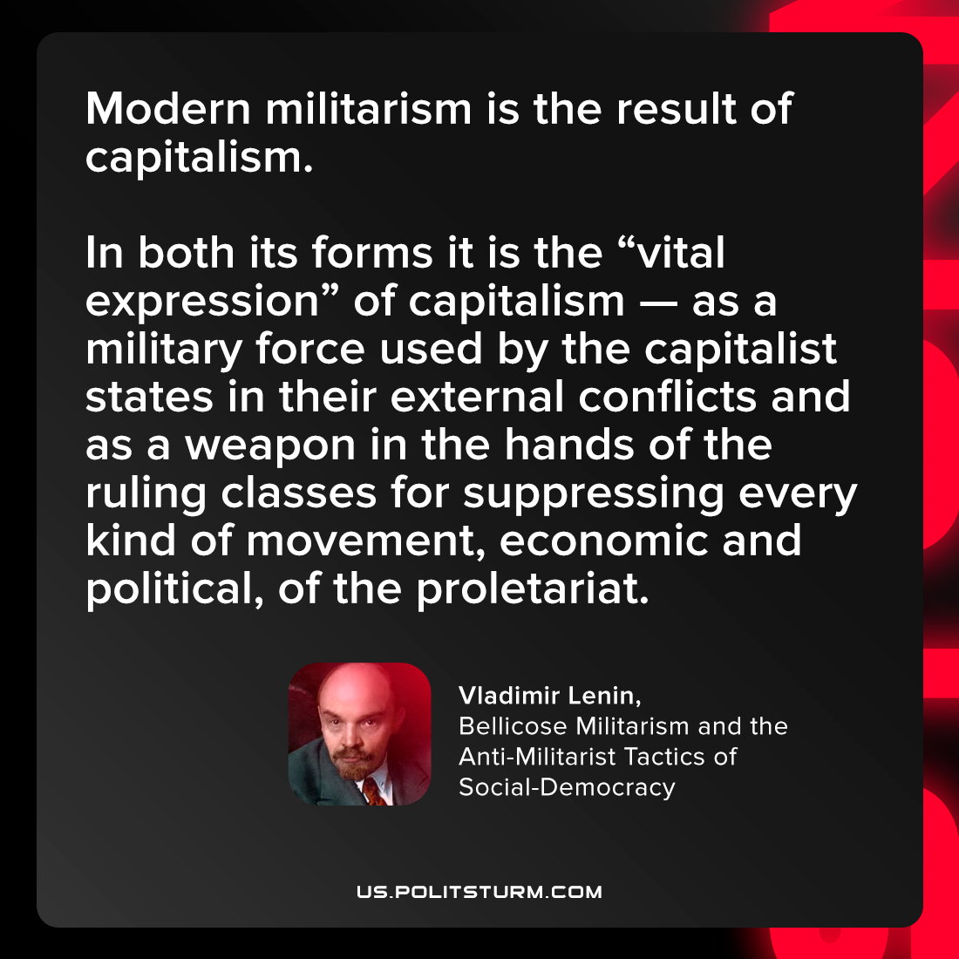

Original article
2022-03-02

Modern militarism is the result of capitalism. In both its forms it is the “vital expression” of capitalism — as a military force used by the capitalist states in their external conflicts and as a weapon in the hands of the ruling classes for suppressing every kind of movement, economic and political, of the proletariat.

Vladimir Lenin, “Bellicose Militarism and the Anti-Militarist Tactics of Social-Democracy”

Original article

