Lenin on Mass Movements and Revolutionary Activity
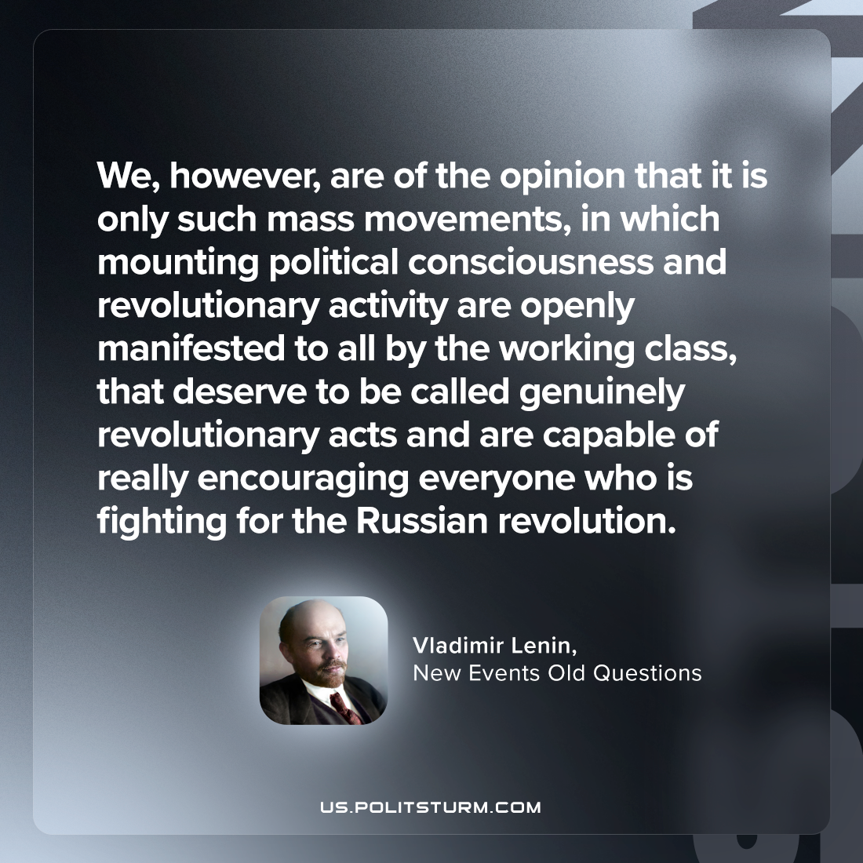

Original article
2023-08-03

"We, however, are of the opinion that it is only such mass movements, in which mounting political consciousness and revolutionary activity are openly manifested to all by the working class, that deserve to be called genuinely revolutionary acts and are capable of really encouraging everyone who is fighting for the Russian revolution."
Vladimir Lenin, New Events Old Questions

Original article

