Lenin on Liberty under Socialism
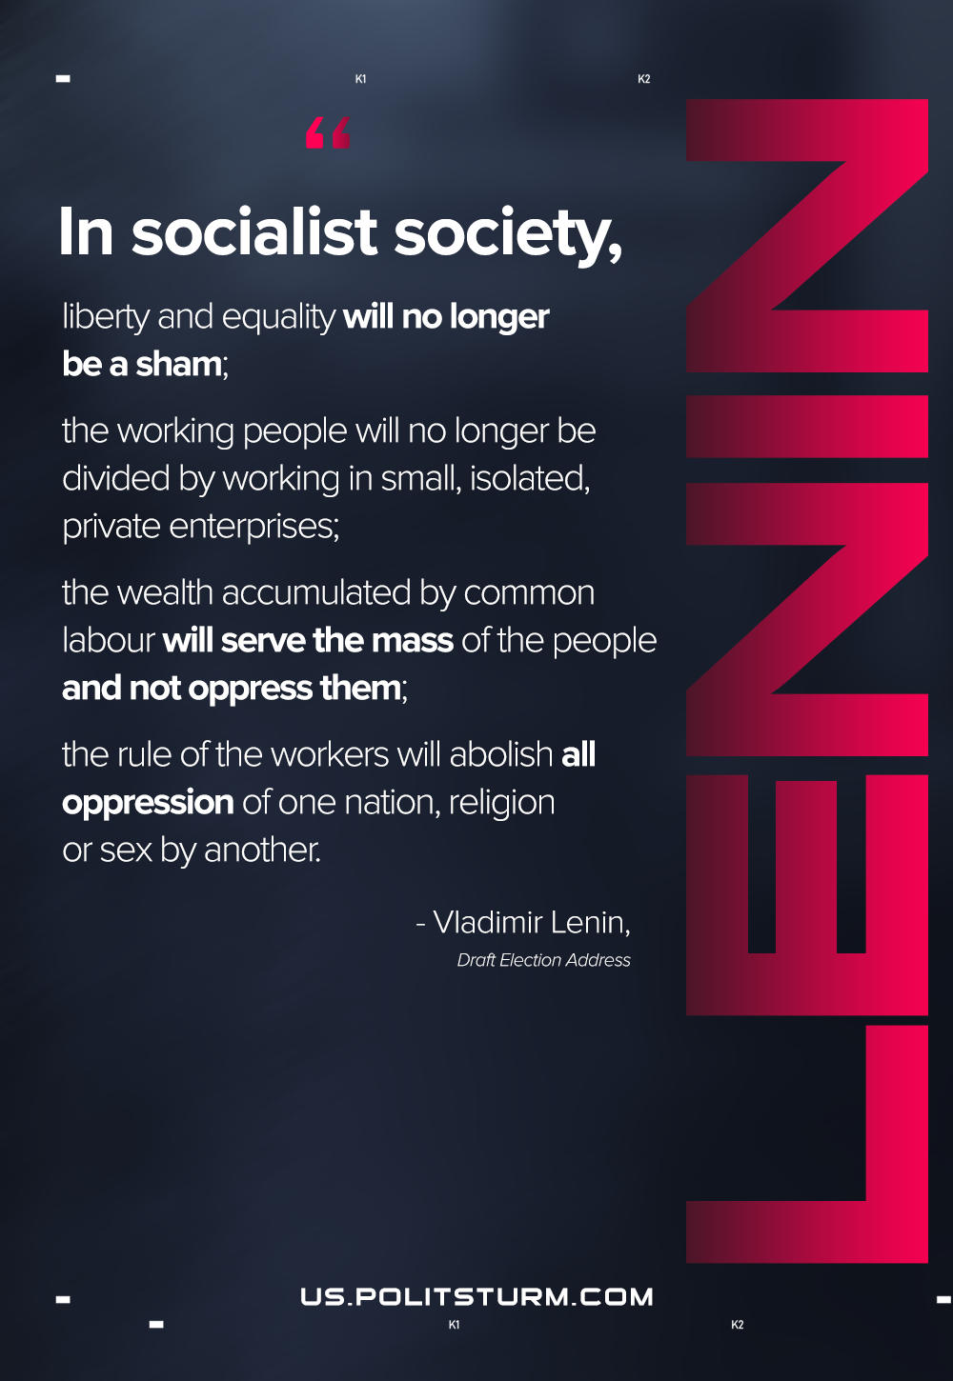

Original article
2021-03-05

In socialist society, liberty and equality will no longer be a sham; the working people will no longer be divided by working in small, isolated, private enterprises; the wealth accumulated by common labour will serve the mass of the people and not oppress them; the rule of the workers will abolish all oppression of one nation, religion or sex by another.
Lenin, Draft Election Address

Original article

