Lenin on Labor Movement
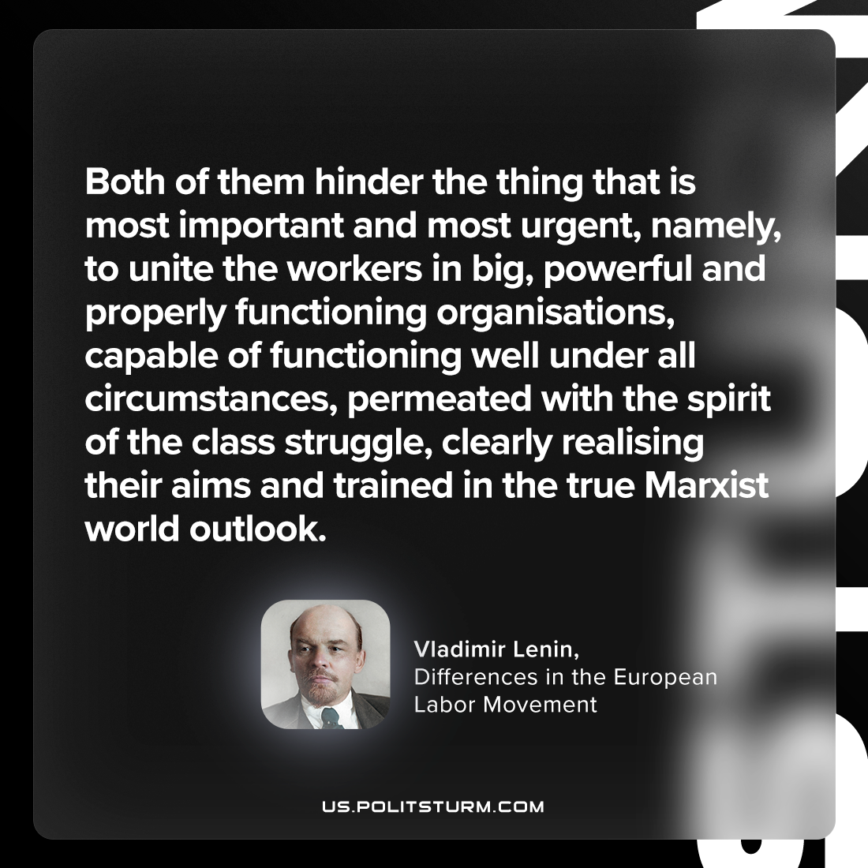

Original article
2023-04-23

"Both of them hinder the thing that is most important and most urgent, namely, to unite the workers in big, powerful and properly functioning organisations, capable of functioning well under all circumstances, permeated with the spirit of the class struggle, clearly realising their aims and trained in the true Marxist world outlook."
Vladimir Lenin, “Differences in the European Labor Movement”

Original article

