Lenin on Internationalists
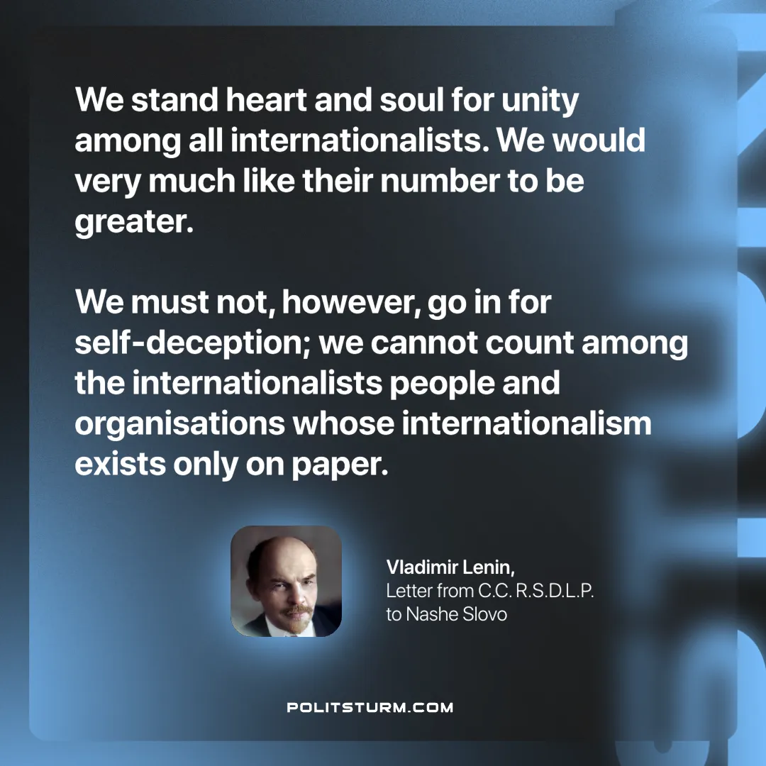

Original article
2025-03-29

"We stand heart and soul for unity among all internationalists. We would very much like their number to be greater. We must not, however, go in for self-deception; we cannot count among the internationalists people and organisations whose internationalism exists only on paper."
Vladimir Lenin, Letter from C.C. R.S.D.L.P. to Nashe Slovo

Original article

