Lenin on Internationalism
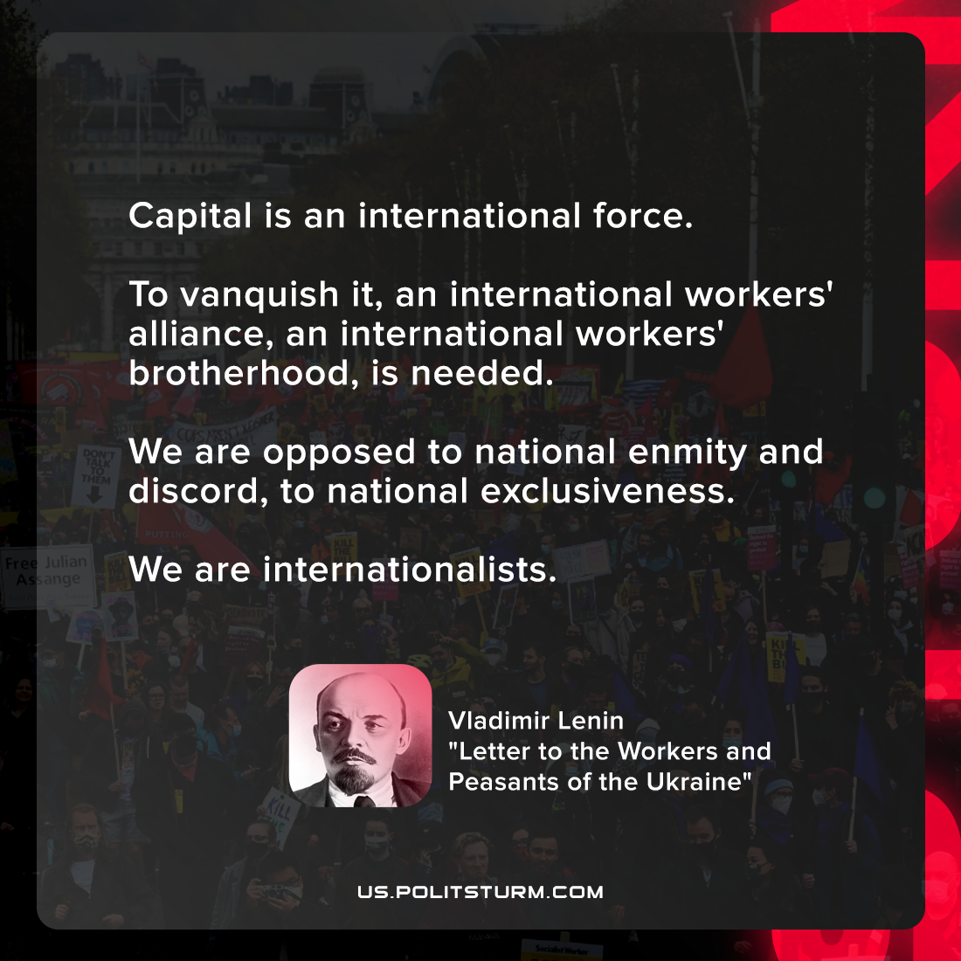

Original article
2021-10-28

Capital is an international force. To vanquish it, an international workers’ alliance, an international workers’ brotherhood, is needed. We are opposed to national enmity and discord, to national exclusiveness. We are internationalists.

Vladimir Lenin, “Letter to the Workers and Peasants of the Ukraine”

Original article

