Lenin on Internationalism in Opposition to Nationalism
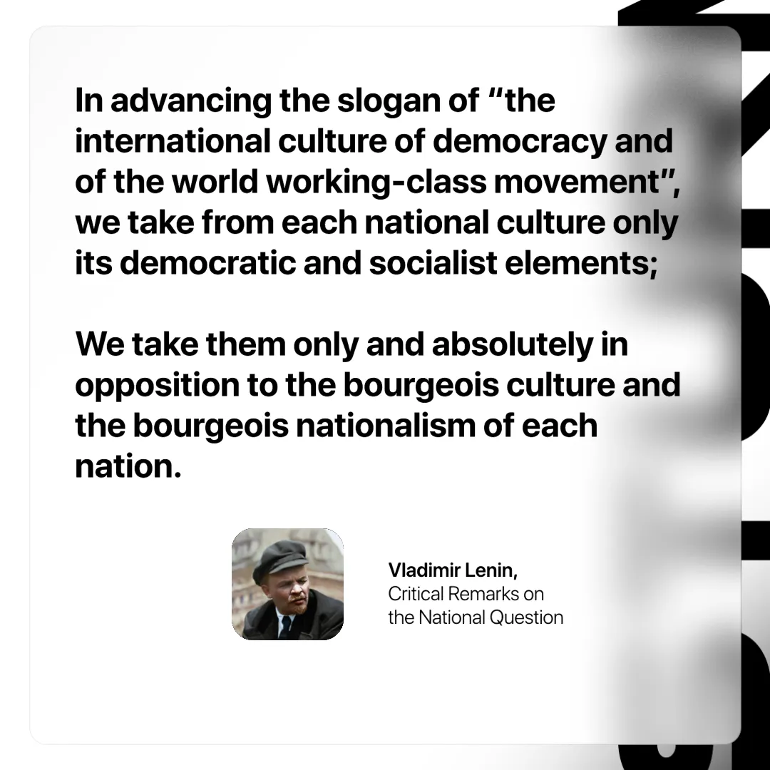

Original article
2024-10-19

“In advancing the slogan of “the international culture of democracy and of the world working-class movement”, we take from each national culture only its democratic and socialist elements; we take them only and absolutely in opposition to the bourgeois culture and the bourgeois nationalism of each nation.”
Vladimir Lenin, Critical Remarks on the National Question

Original article

