Lenin on Increased Wealth, Increased Appropriation
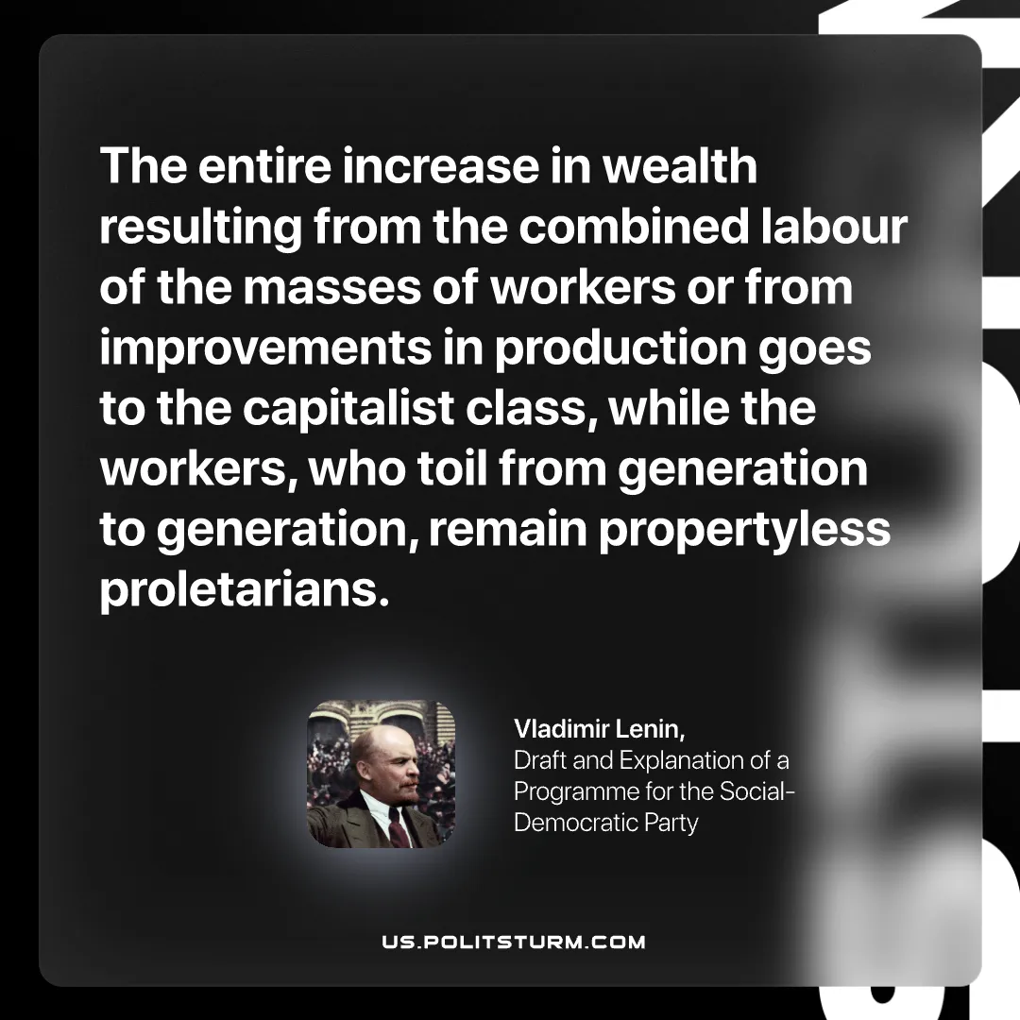

Original article
2026-10-24

The entire increase in wealth resulting from the combined labour of the masses of workers or from improvements in production goes to the capitalist class, while the workers, who toil from generation to generation, remain propertyless proletarians.
Vladimir Lenin, Draft and Explanation of a Programme for the Social-Democratic Party

Original article

