Lenin on Imperialist Wars and Preserving of Capitalism
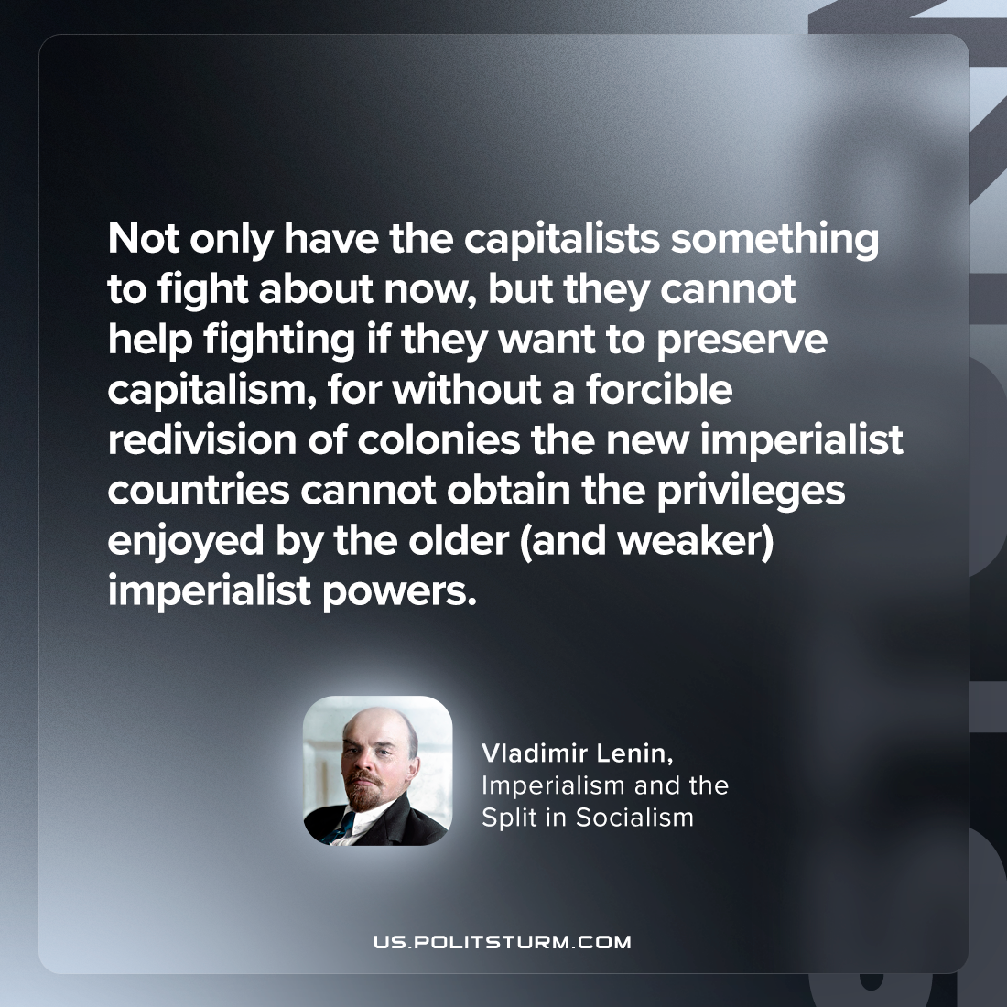

Original article
2023-08-26

"not only have the capitalists something to fight about now, but they cannot help fighting if they want to preserve capitalism, for without a forcible redivision of colonies the new imperialist countries cannot obtain the privileges enjoyed by the older (and weaker) imperialist powers."
Vladimir Lenin, Imperialism and the Split in Socialism

Original article

