Lenin on Imperialist Era
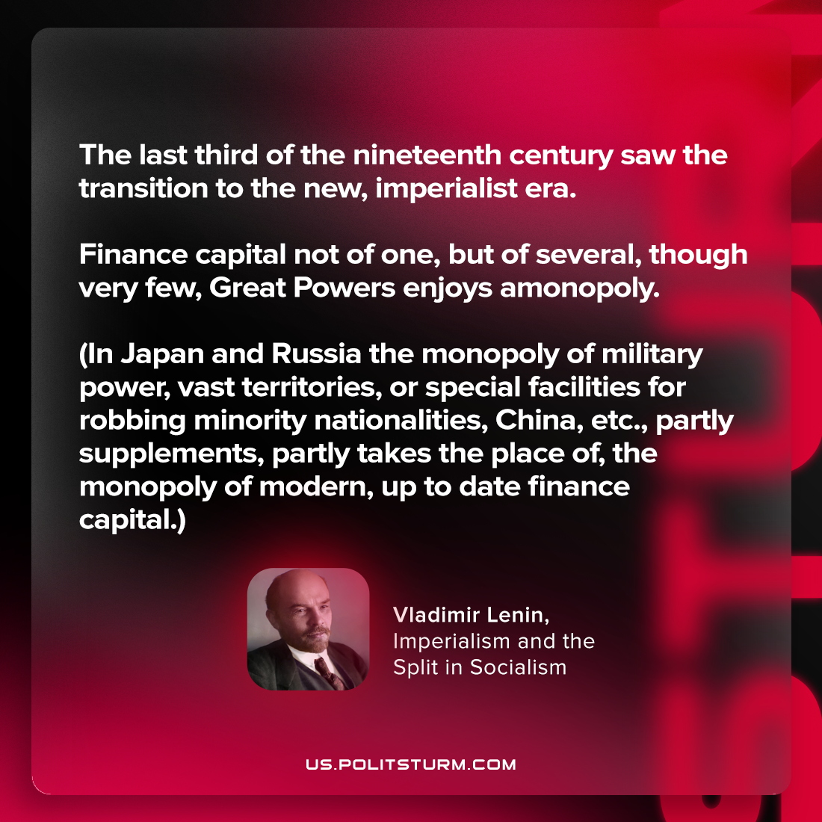

Original article
2023-07-15

"The last third of the nineteenth century saw the transition to the new, imperialist era. Finance capital not of one, but of several, though very few, Great Powers enjoys a monopoly. (In Japan and Russia the monopoly of military power, vast territories, or special facilities for robbing minority nationalities, China, etc., partly supplements, partly takes the place of, the monopoly of modern, up-to-date finance capital.)"
Vladimir Lenin, Imperialism and the Split in Socialism

Original article

