Lenin on Imperialism
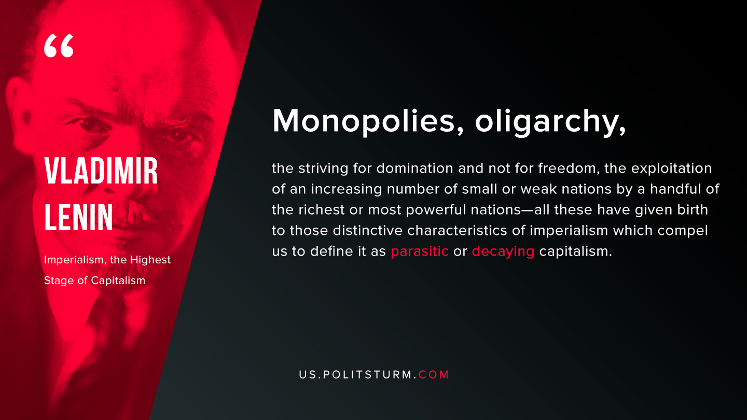

Original article
2019-08-25

Monopolies, oligarchy, the striving for domination and not for freedom, the exploitation of an increasing number of small or weak nations by a handful of the richest or most powerful nations – all of these have given birth to the distinctive characterictics of imperialism which compel us to define it as parasitic or decaying capitalism.
Vladimir Lenin “Imperialism, the Highest Stage of Capitalism”

Original article

