Lenin on Imperialism Fostering Reaction
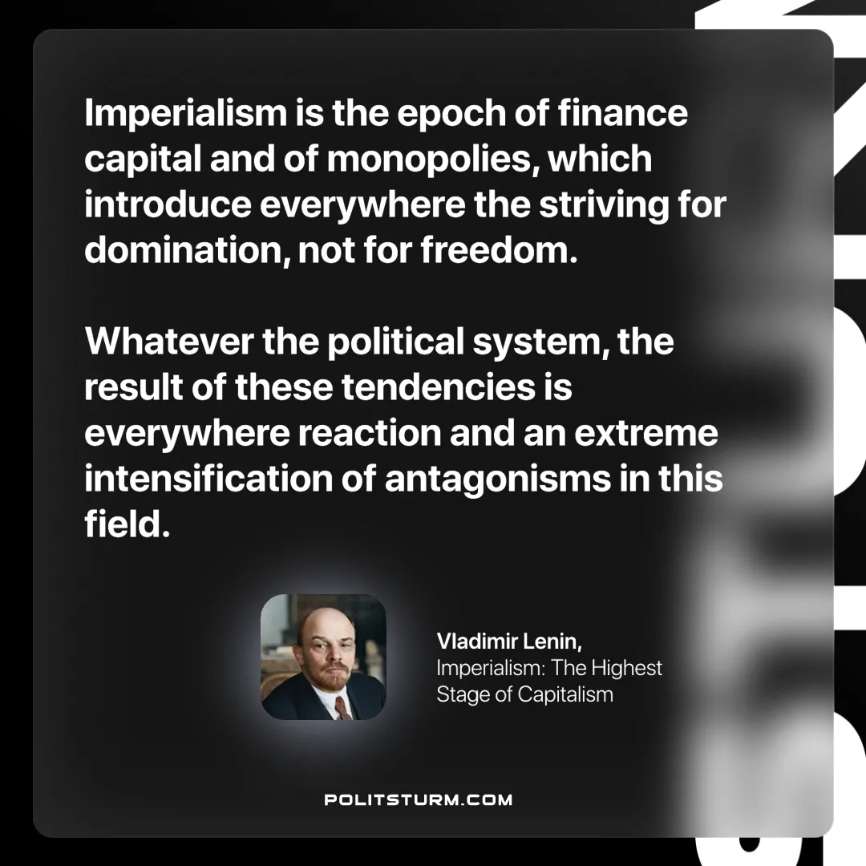

Original article
2024-11-02

“Imperialism is the epoch of finance capital and of monopolies, which introduce everywhere the striving for domination, not for freedom. Whatever the political system, the result of these tendencies is everywhere reaction and an extreme intensification of antagonisms in this field.”
Vladimir Lenin, Imperialism: The Highest Stage of Capitalism

Original article

