Lenin on Imperialism and Socialisation of Production
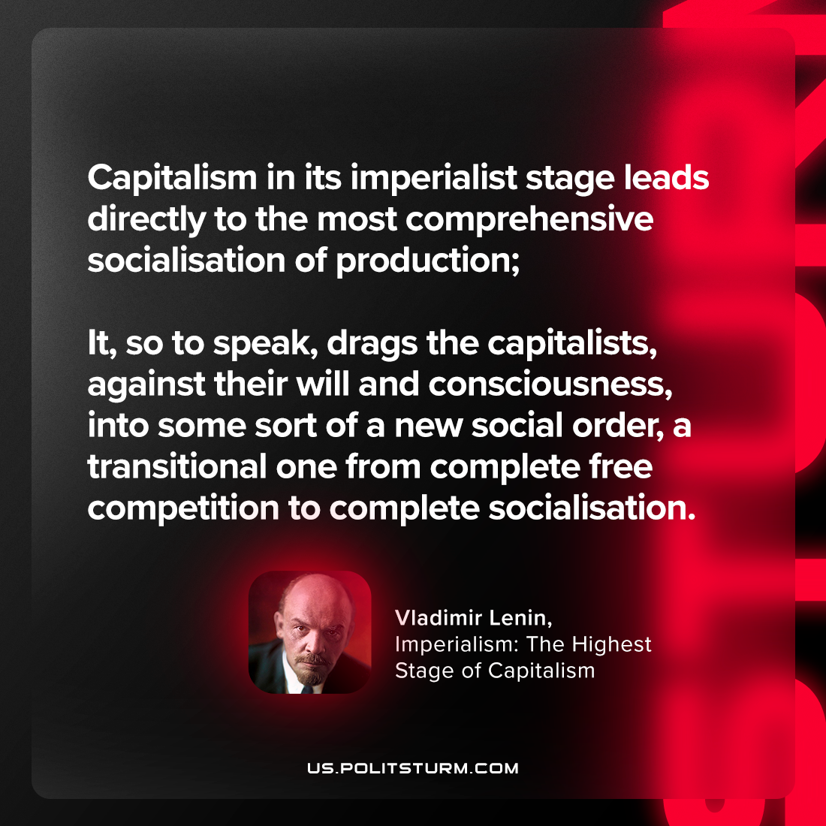

Original article
2023-08-15

"Capitalism in its imperialist stage leads directly to the most comprehensive socialisation of production; it, so to speak, drags the capitalists, against their will and consciousness, into some sort of a new social order, a transitional one from complete free competition to complete socialisation."
Vladimir Lenin, Imperialism: the Highest Stage of Capitalism

Original article

