Lenin on Imperialism and Finance Capital
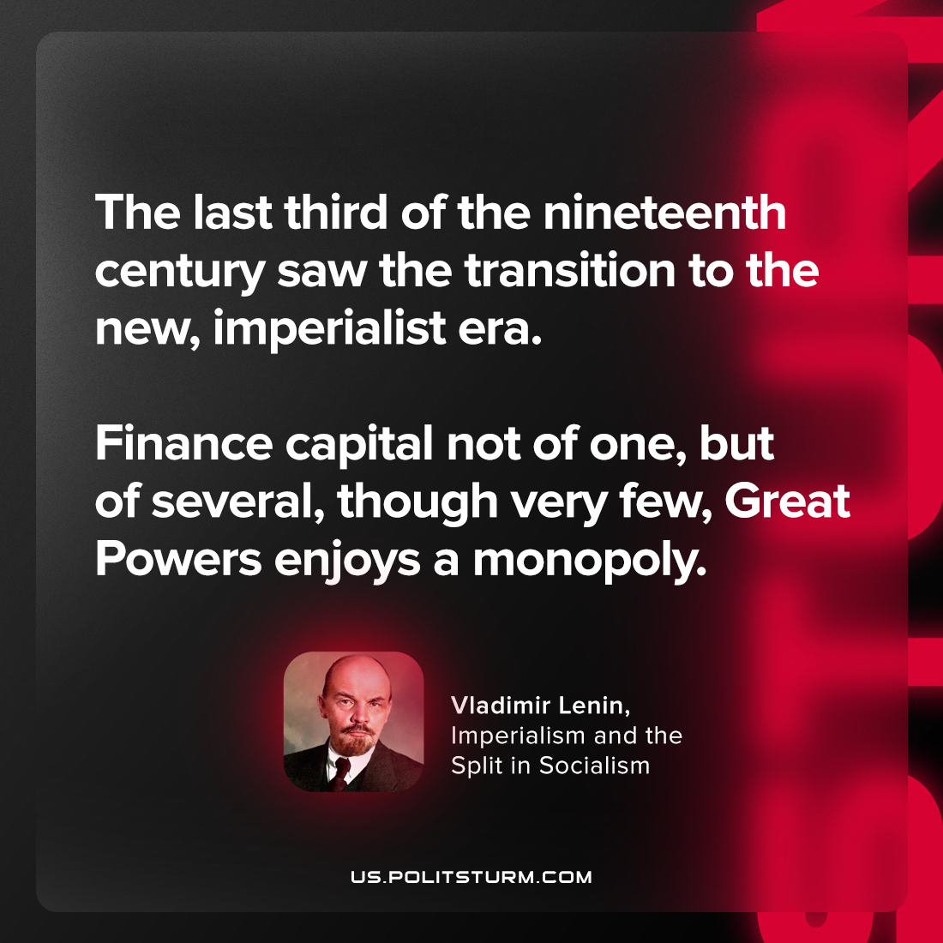

Original article
2023-06-27

"The last third of the nineteenth century saw the transition to the new, imperialist era. Finance capital not of one, but of several, though very few, Great Powers enjoys a monopoly."
Vladimir Lenin, Imperialism and the Split in Socialism

Original article

