Lenin on Imperialism
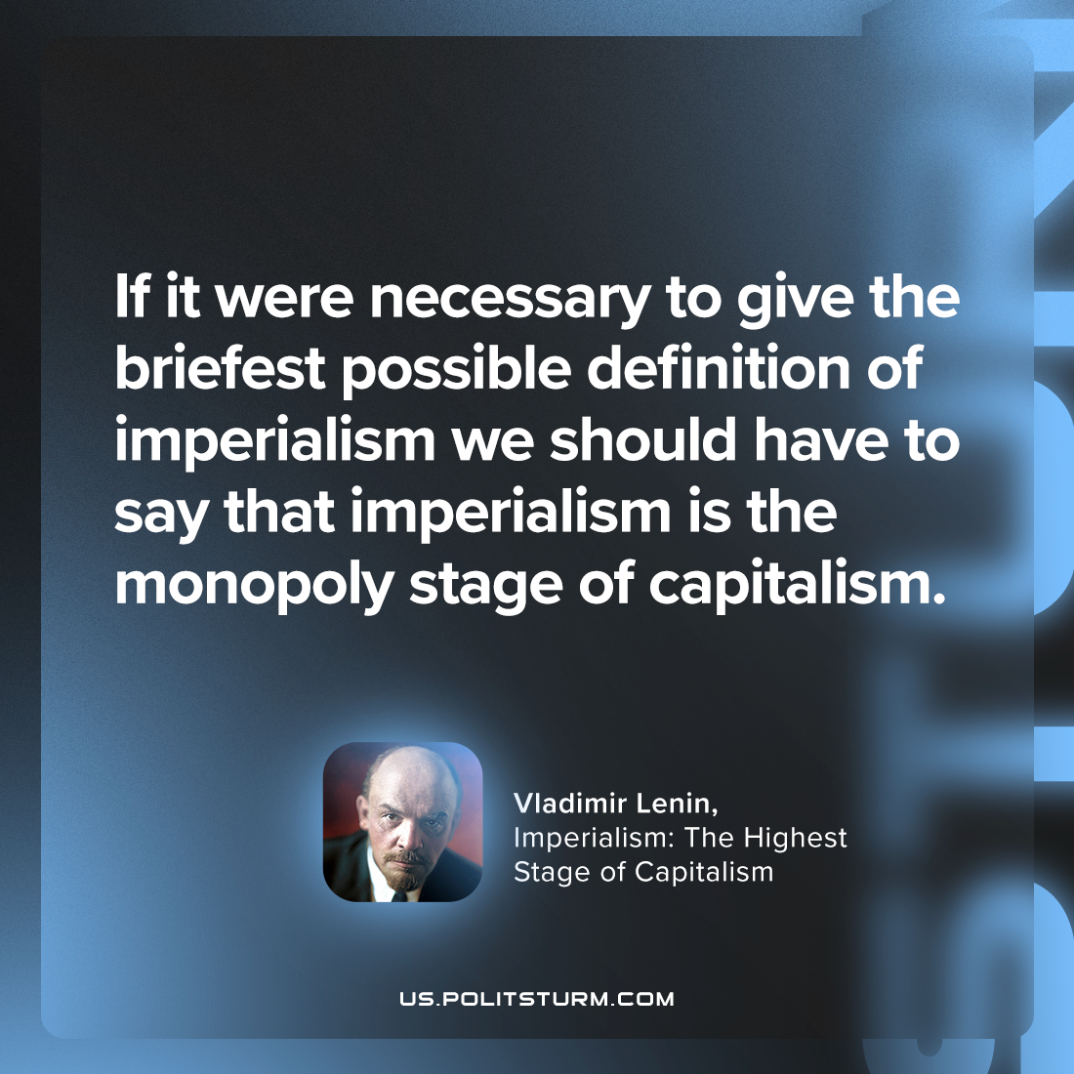

Original article
2023-04-08

"If it were necessary to give the briefest possible definition of imperialism we should have to say that imperialism is the monopoly stage of capitalism."
Vladimir Lenin, “Imperialism: the Highest Stage of Capitalism”

Original article

