Lenin on Imperialism
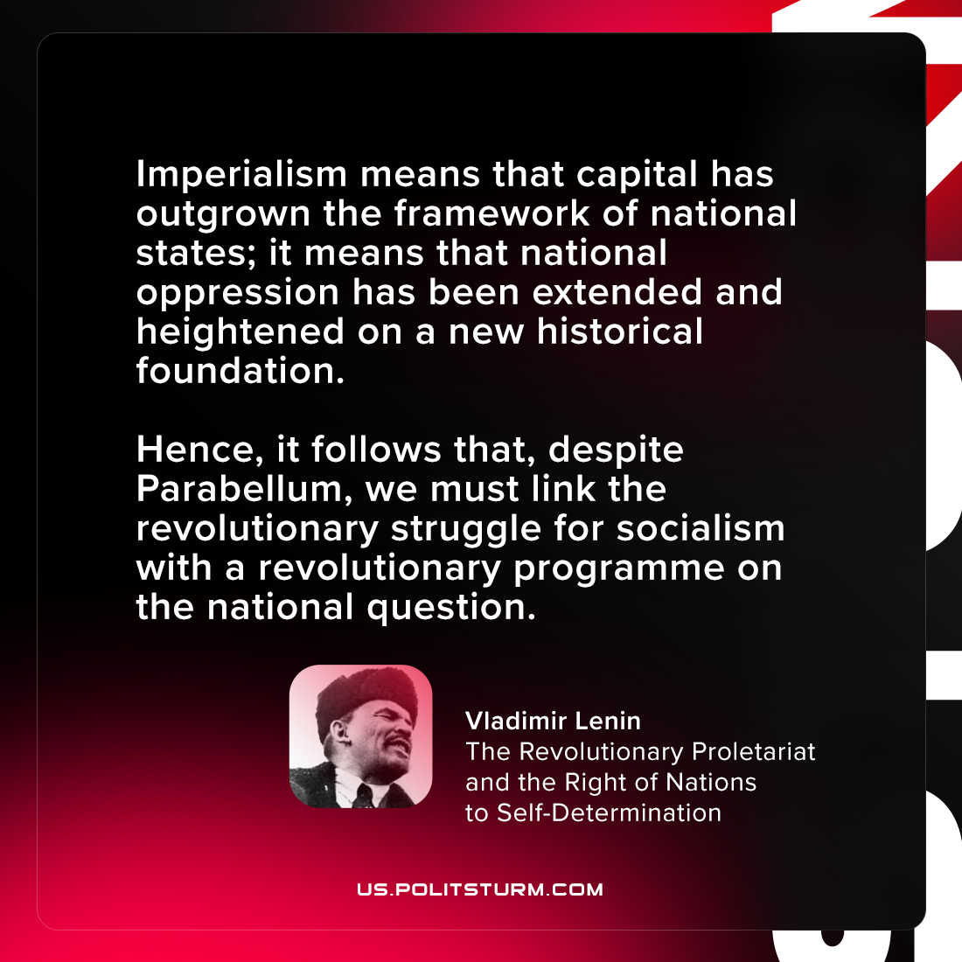

Original article
2021-08-21

Imperialism means that capital has outgrown the framework of national states; it means that national oppression has been extended and heightened on a new historical foundation. Hence, it follows that, despite Parabellum, we must link the revolutionary struggle for socialism with a revolutionary programme on the national question.

Vladimir Lenin, “The Revolutionary Proletariat and the Right of Nations to Self-Determination”

Original article

