Lenin on Imperialism
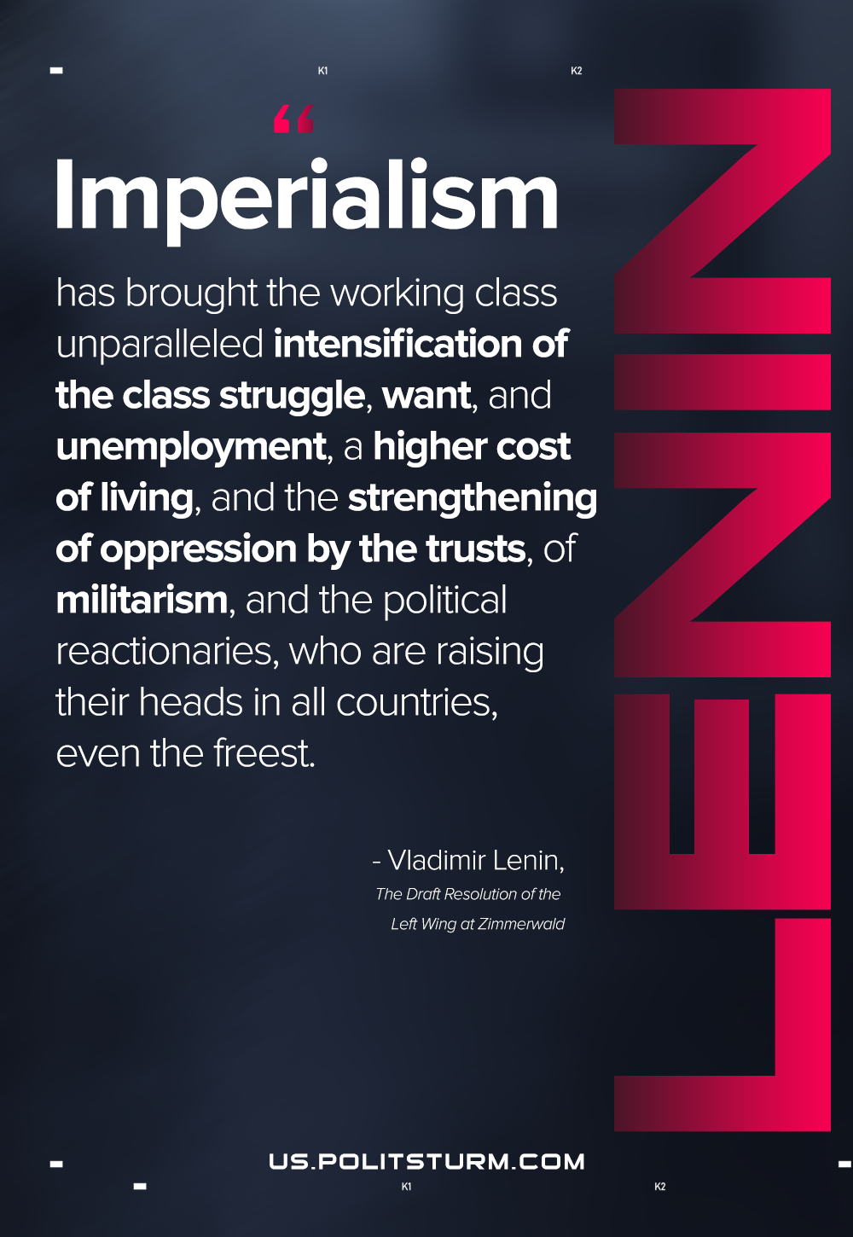

Original article
2021-05-01

Imperialism has brought the working class unparalleled intensification of the class struggle, want, and unemployment, a higher cost of living, and the strengthening of oppression by the trusts, of militarism, and the political reactionaries, who are raising their heads in all countries, even the freest.
The Draft Resolution of the Left Wing at Zimmerwald

Original article

