Lenin on Imperialism
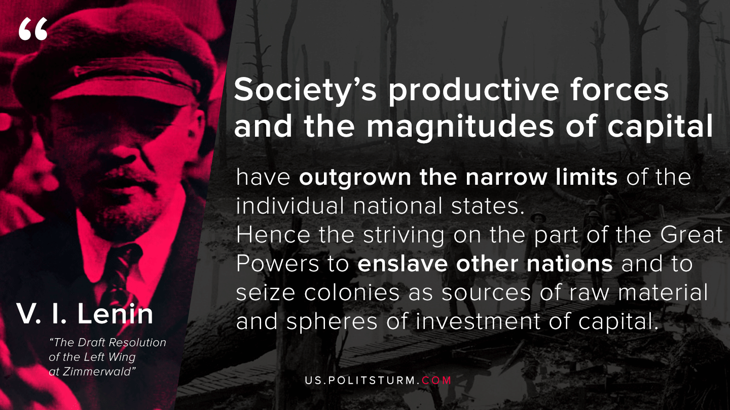

Original article
2020-04-30

Society’s productive forces and the magnitudes of capital have outgrown the narrow limits of the individual national states. Hence the striving on the part of the Great Powers to enslave other nations and to seize colonies as sources of raw material and spheres of investment of capital.
Lenin, The Draft Resolution of the Left Wing at Zimmerwald

Original article

