Lenin on Imperialism
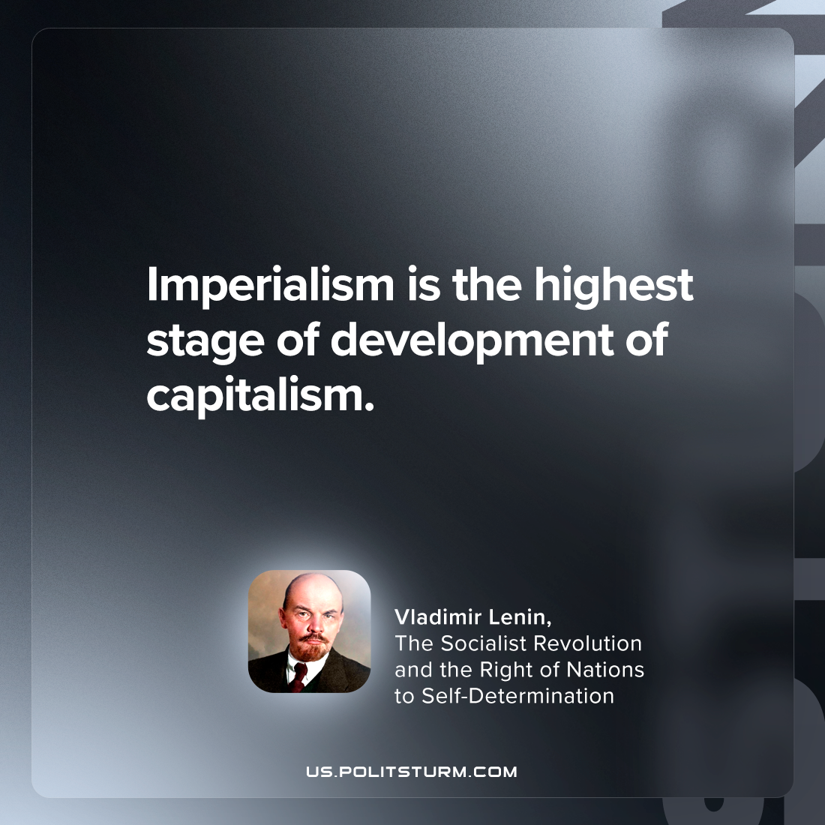

Original article
2024-02-12

"Imperialism is the highest stage of the development of capitalism"
Vladimir Lenin, The Socialist Revolution and the Right of Nations to Self-Determination

Original article

